CityHunter

Scope of Work

1.5



Table of Contents

Mobile - iOS App 3

General Information 3

Technical Solution for Development 3

API List 3

Opening the App (First Time / Open / Multitasking) 4

Login/Register 4

My Profile 5

Hunt 8

Restaurant/Deal 11

Purchase Deal 15

Connect 16

Action 17

My Stuff 23

Settings 23

Other General Requirements 27

Emails 29

Notifications 29

Copy 29

Web - Content Management 32

Web - Venue Management 33

Sample Screens 33

# Mobile - iOS App

## General Information

The iOS App will be published through Apple’s App Store. It will be adapted to support both screen size formats of iPhone 4S and iPhone 5 without letterboxing.

Design files are ready and will be supplied in PSD format. At request, the elements can be individually exported in PNG format.

Check the Keynote for functionality and content wireframe.

## Technical Solution for Development

* Database & Functions: PostgreSQL
* Additional Database Option: Redis
* Coding: Python with Django as web framework (faster and stable)
* Coding Option: Javascript with Node.js (slower but good for an eventual future webapp)

## API List

* Foursquare (<https://developer.foursquare.com/>): venues, geolocation(?);
* Facebook (<http://developers.facebook.com/>): registrations, login, invites, social media sharing;
* Tweeter (<https://dev.twitter.com/>): registrations, login, invites(?), social media sharing;
* Weibo (<http://open.weibo.com/wiki/API%E6%96%87%E6%A1%A3_V2/en>): social media sharing;
* PayPal (<https://developer.paypal.com/>): payments;
* Moneris e-Select Plus (<https://developer.moneris.com/Default.aspx>): payments;
* Moneris e-Select Plus Vault (<http://www.moneris.com/ProductsAndServices/Products/OnlinePayment/eSelectPlus.aspx>): payments;

Other as needed.

## Opening the App (First Time / Open / Multitasking)

First time a user opens the App on his phone, will have a 5-screen slide tutorial that will highlight the main features. The slides can be swiped back and forth. The last slide will reveal the first screen of the App.

The App will open at the last screen the user was before closing/switching away from it.

The App will have password protection. If enabled, it will require a 4-digit passcode to grant access to the application. Users can reset the passcode. By doing so, will have to re-login (Email, Facebook, Twitter) before using the App again. The passcode can be managed (toggled, changed) from Settings. After the code has been successfully introduced, the app will open at the last screen the user was before closing/switching away from it.

If the user has new notifications (likes, comments or new followers/requests) since last time the App has been open, a small pop-up will hover over Connect Icon in the Iconbar displaying # Likes, # Comments and # New Folowers/Requests (it can be 0 and shows if at least one of the 3 sections has a minimum of 1 new update). Clicking this pop-up will open Connect and the 3 counters will be reset.

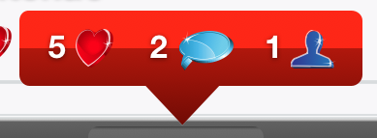

## Login/Register

The first screen will allow users to Login or Register. New users will have to Register first.

The Registration screen will offer 3 registration options: Email, Facebook and Twitter.

The Email Registration screen requires Username, First Name, Last Name, Email, Confirm Email and Password. The fields will have a real-time reviewing that will detect and signal faulty elements like: username already in use, inappropriate entries and invalid or email not matching. The two links in the bottom page will open Terms & Conditions and Privacy policy in Safari.

Registrations with Facebook and Twitter will require standard procedures for setting the permissions. We will grab all the information available (full name, email, phone #, address, date of birth, location, etc.) and store it in our database. The only information used will be First Name, Last Name and Email. The next registration screen will show these (if available) and require additional info: Username and Password. This form will also feature real-time reviewing.

Clicking Register will take the user to the Hunt screen with a “Thank you for registering with CityHunter.” pop-up.

The Login screen will allow existing users to type in the Email and Password or login with Facebook or Twitter. After a successful login, the App will open in Hunt screen.

Referred By field is where a new user can enter his referral email or username. The system will match the data and reward the referral with the reward coins setup in the CMS.

## My Profile

My Profile screen will always be accessible from the # Coins in the Top Bar.

It will display: Profile Picture, Username, # Check-Ins, # Pictures, # Followers, # Following, # Redeemed, personal history Newsfeed and the Icon Bar.

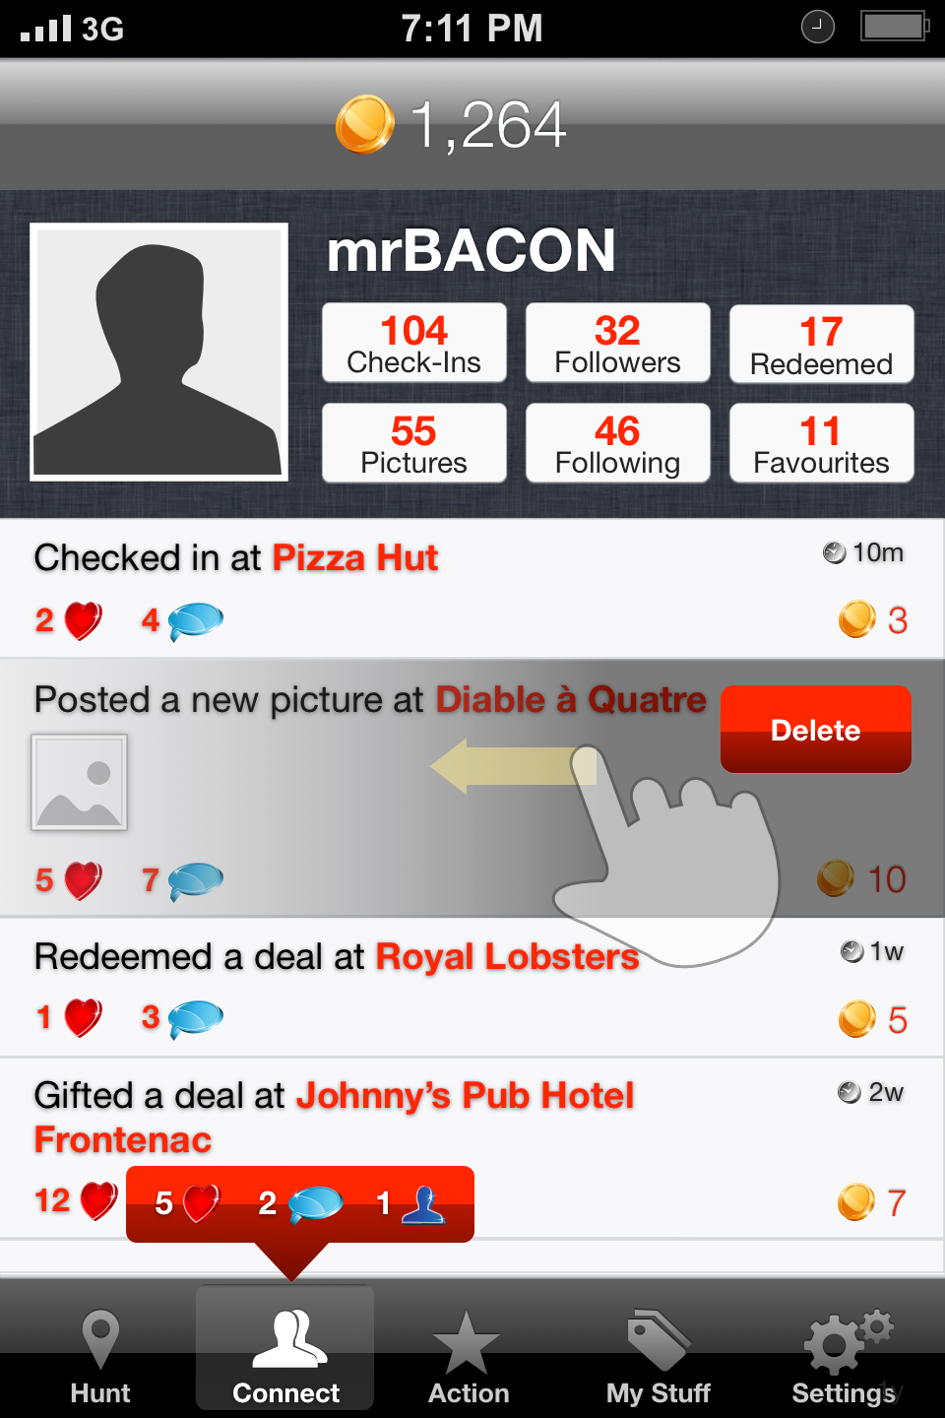

Clicking on the Profile Picture will open the Camera / Choose from Library for Profile Picture change.

The 6 buttons under the Username will take to their respective screens (i.e.: My Check-Ins, My Pictures, My Followers, People I Follow and Redeemed Deals).

The Newsfeed will have the list of activity in reverse chronological order (the most recent post appears first). Each item will have the Message, will link to the appropriate section, the picture (if applicable), # Likes, # Comments, # Coins Rewarded for activity and the Time since it was published.

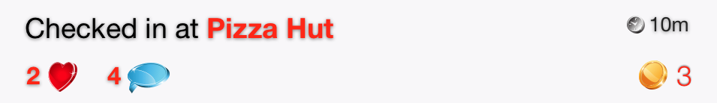

This rule applies everywhere: If an action doesn’t have any reward coins, it will not be shown. We don’t want to see “0 coins”.

Clicking on the Heart icon will count as 1 Like and he will be granted the # Coins for this action and which will be immediately visible on the front-end.

Clicking on the Comment icon will bring the comments screen with the Profile Picture of the user who posted, Username, # Coins, the Message (e.x.: “Checked in at Restaurant Name”), Time since, # Likes, # Comments , # Coins Earned, shortlist of users who liked this (if exist), the comments and the comment box. No Iconbar.

Here, the user can comment and answer to other users’ comments. The special key “@” will pull a list of matching usernames (the list will be populated from “my followers” + the users who commented above). The list will update in real-time as the user is typing in the name. In the matching names list we will have the Profile Picture, Usrename and # Coins. Choosing one user will fill it In the comment box in the following form: “@Username”. This will be a hyperlink to his respective profile.

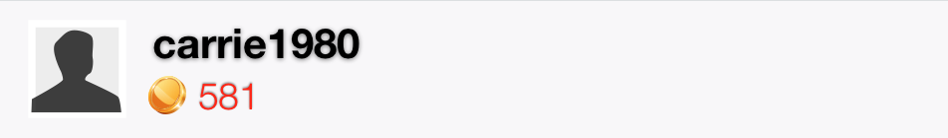

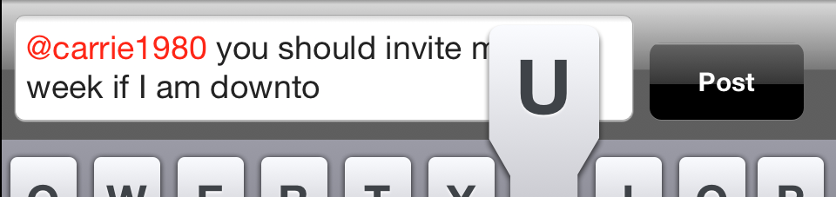

Each comment in the feed will display the Profile Picture of the user who posted the comment, Username, Message, Time since, # Likes, # Coins Earned. The comments will be displayed in reverse chronological order.

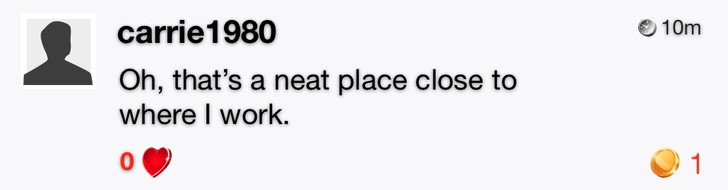

**My Check-Ins** displays the list of restaurants where I have checked in. It is similar for someone else’s check-ins. The feed will display the Restaurant Picture, Restaurant Name, Deal Brief, Dollar Price and Coin Price.

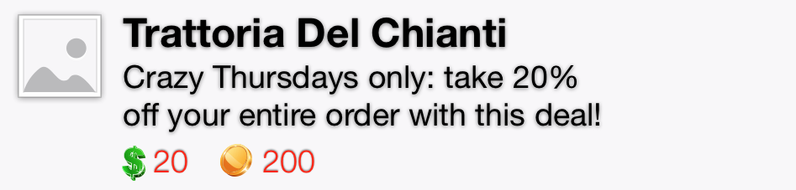

**My Pictures** (similar to others pictures) will have a scrolling list of 4 on a row small-sized thumbnails in reverse chronological order.



Each picture will point to the feed itself showing the Profile Picture of the author, Username, # Coins, Time since, medium-sized image, Message with Restaurant Name, # Likes, liked list and # Comments with comment feed. Further, clicking on the image will open it in full size. Here it can be moved around as well as zoomed in and out by pinching.

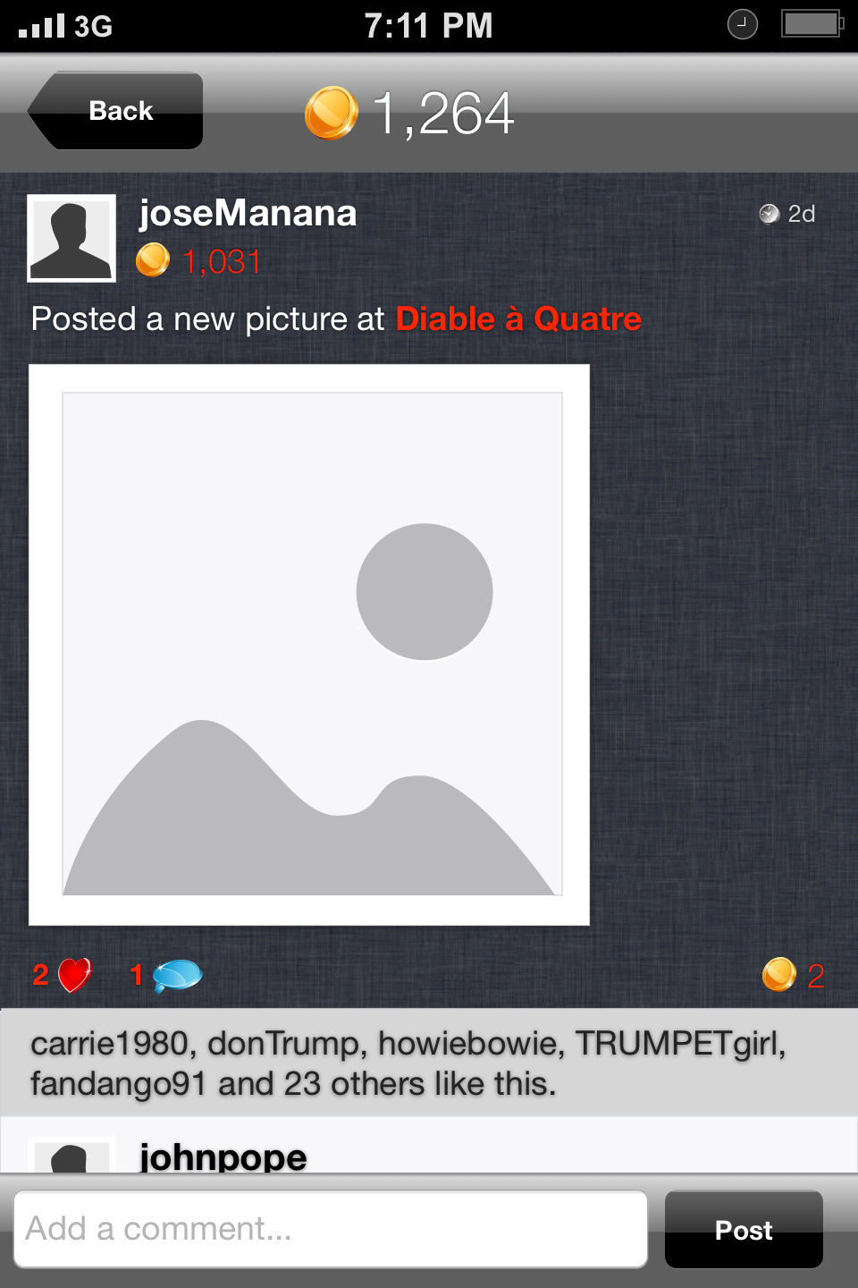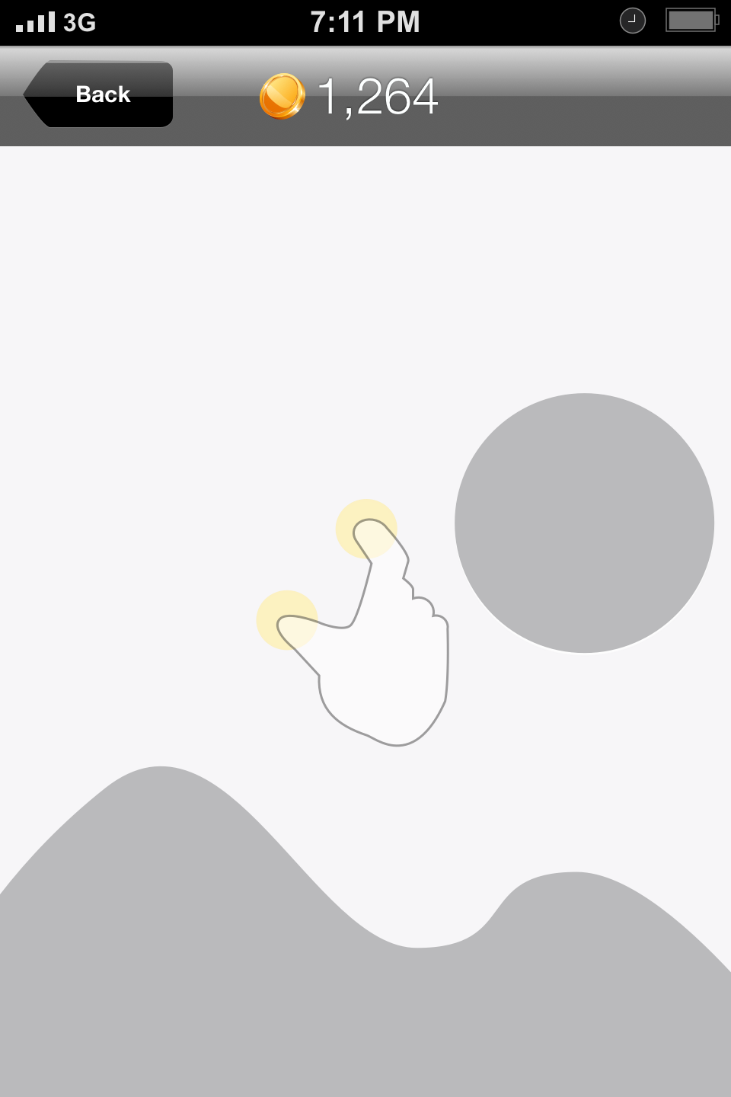

The **Followers** List (or **My Followers**) and **Following** List (or **People I Follow**) are similar. Followers/My Followers have the Profile Picture, Username, # Coins and the Follow/Unfollow toggle. People I follow will instead have the Unfollow or Requested button. Requested status will be used if the profile has been set to Private from Settings.

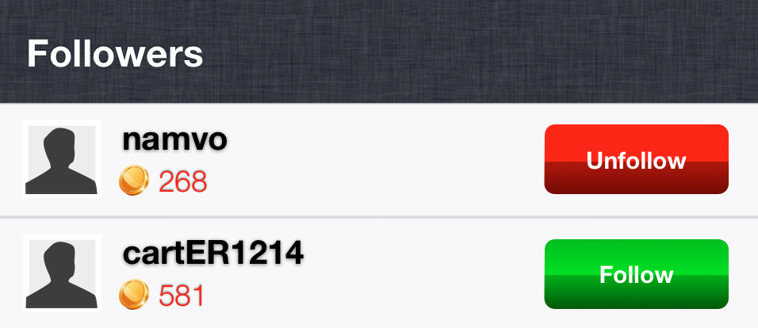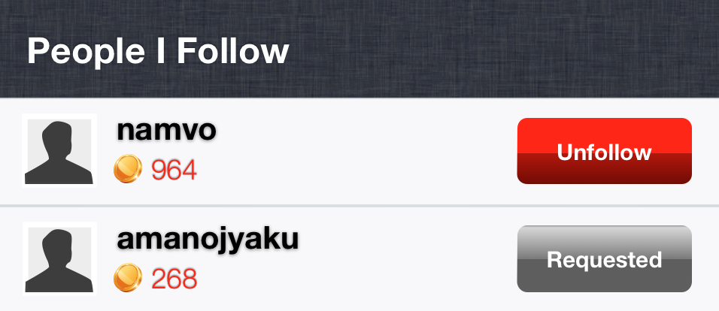

The same goes for watching somebody else’s followers/following.

**My Favourites** will display the favorite restaurants that I added to my list from the Restaurant page – by clicking on the star (switch) found on every Restaurant/Deal page. The star is only visible to me.

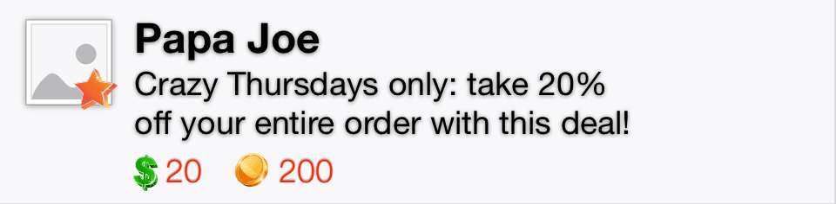

## Hunt

Hunt Screen will feature a **Map** with a Search box for finding restaurants, a “Get My Location” button and a List button. The List button will switch to a list of nearby restaurants. The Map will locate user’s current position when opened and display nearby restaurants using Foursquare API.

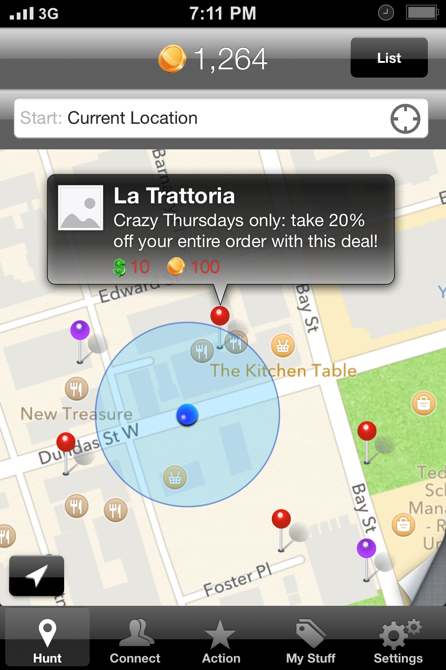

The dollar or coin-based deals will be represented with different colored pins. Each pin will display a pop-up on click with the Restaurant Main Image, Deal Short Description, Coin and/or Dollar value. Clicking anywhere on the pop-up opens the Restaurant/Deal screen.

Note that here we will only display Deal 1 by default, even if the restaurant has 2 or 3 deals.

The lower right corner of the map will trigger a “half-page curl” similar to iOS Maps using XBPageCurl (<https://github.com/xissburg/XBPageCurl>) or similar. This will reveal the search filters: Category and Deal Type.

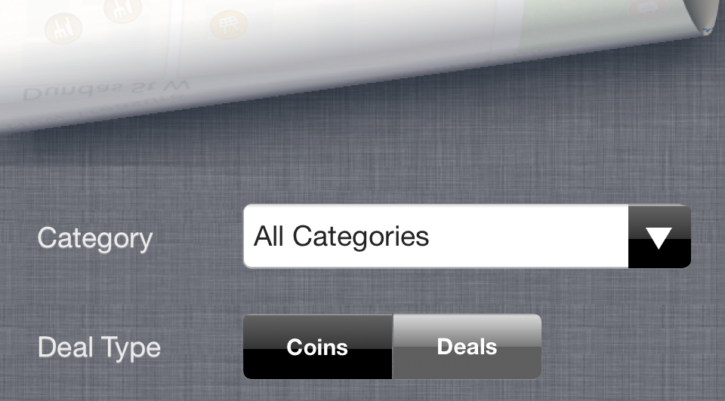

**The Categories are:**

* Afghan Restaurant
* African Restaurant
* American Restaurant
* Arepa Restaurant
* Argentinian Restaurant
* Asian Restaurant
* Australian Restaurant
* BBQ Joint
* Bagel Shop
* Bakery
* Brazilian Restaurant
* Breakfast Spot
* Burger Joint
* Burrito Place
* Café
* Cajun / Creole Restaurant
* Caribbean Restaurant
* Chinese Restaurant
* Coffee Shop
* Cuban Restaurant
* Cupcake Shop
* Delis / Bodegas
* Dessert Shop
* Dim Sum Restaurant
* Diner
* Distillery
* Donut Shop
* Dumpling Restaurant
* Eastern European Restaurant
* Ethiopian Restaurant
* Falafel Restaurant
* Fast Food Restaurant
* Filipino Restaurant
* Fish & Chips Shop
* Food Truck
* French Restaurant
* Fried Chicken Joint
* Gastropub
* German Restaurant
* Gluten-free Restaurant
* Greek Restaurant
* Hot Dog Joint
* Ice Cream Shop
* Indian Restaurant
* Indonesian Restaurant
* Italian Restaurant
* Japanese Restaurant
* Juice Bar
* Korean Restaurant
* Latin American Restaurant
* Mac & Cheese Joint
* Malaysian Restaurant
* Mediterranean Restaurant
* Mexican Restaurant
* Middle Eastern Restaurant
* Molecular Gastronomy Restaurant
* Mongolian Restaurant
* Moroccan Restaurant
* New American Restaurant
* Peruvian Restaurant
* Pizza Place
* Portuguese Restaurant
* Ramen / Noodle House
* Restaurant
* Salad Place
* Sandwich Place
* Scandinavian Restaurant
* Seafood Restaurant
* Snack Place
* Soup Place
* South American Restaurant
* Southern / Soul Food Restaurant
* Spanish Restaurant
* Paella Restaurant
* Steakhouse
* Sushi Restaurant
* Swiss Restaurant
* Taco Place
* Tapas Restaurant
* Tea Room
* Thai Restaurant
* Turkish Restaurant
* Vegetarian / Vegan Restaurant
* Vietnamese Restaurant
* Winery

**The Deal Types are:**

* Coins (only the deals that can be purchased with coins)
* Deals (all the deals: dollars, coins, mixed)

The **List** will display all the locations based on proximity, the closest on top. The only exception will be the Featured locations, which have priority and go directly on top of the list. The distance between each location and the user will also be shown.

Note that here we will only display Deal 1 by default, even if the restaurant has 2 or 3 deals.

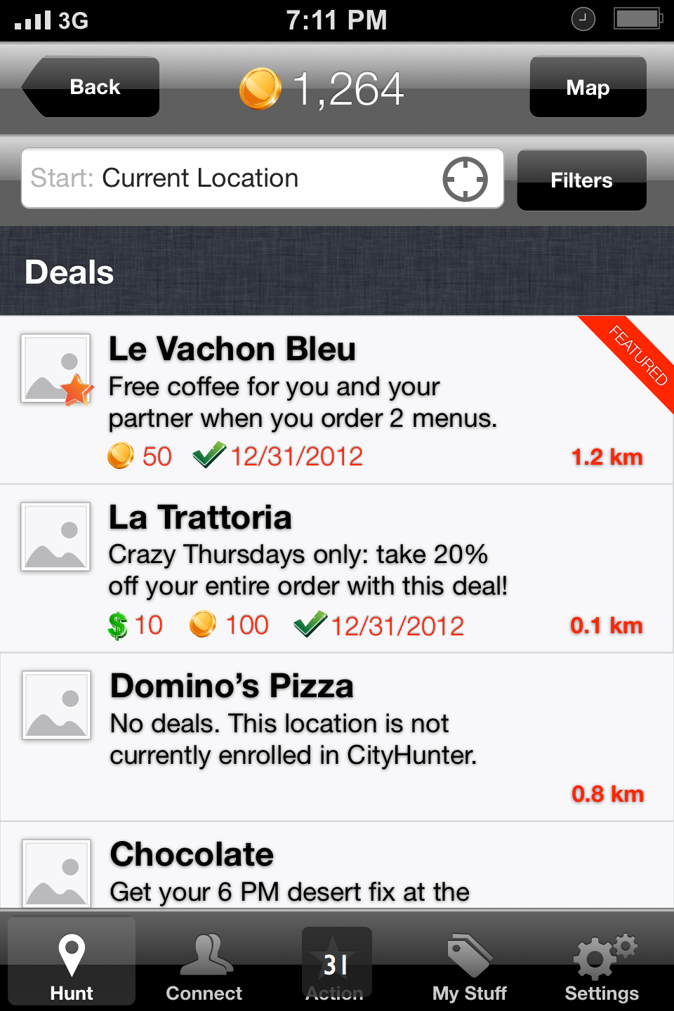

The Featured locations can be distinguished by the display of a banner. Each item will have the Main Restaurant Image, Favourite star (if applicable), Restaurant Name, Short Deal Description, Coin and/or Dollar value, Deal Expiry Date and Distance.

Users will be able to perform a search by entering the name of a restaurant they know, or a location (city) or even a cuisine type. They will also be able to reset the search and location by clicking the “Get My Location” button. The List Search Filters will allow detecting current location, choosing a Category and a Deal Type.

In the List View, we will search for and display a maximum of 20 restaurants. Scrolling all the way to the bottom of the list will search again and add the next 20 restaurants and so on, unlimited. The message displayed at the bottom of the list will be: “Scroll down to load more”.

The search bar will perform as follows:

* Type in a location, the map will go there and will update based on the filters.
* Type in a restaurant's name, the map will go there and will only show that restaurant. If there is more than one with that name, will go to the closest one.
* Type in a cuisine type, the map will center on the closest restaurant that type but it will show other restaurants that fit the cuisine type searched.
* Move the map and it will update based on the filters, overwriting any previous search.
* Click on “Get My Location” button and the map will centre on the current location and update itself based on the filters.
* Switching between Map and List will not interfere with the search.

## Restaurant/Deal

One Restaurant has 3 Deal spots and only one Deal active at a time. The restaurants will be able to setup more than one Deal in the Venue Management Website then decide which one is active. The system will also determine which deal is currently active, based on Deal availability date (when the deal starts and ends). The restaurants not yet affiliated to CityHunter will allow Voting for future affiliation proposal. If a Restaurant affiliated to CityHunter doesn’t have any Deal active at a certain time, the app will display a message on the Restaurant page.

Here are some rules to apply:

* Restaurant not partner with us = Voting status;
* Restaurant is partner with us and has a deal = Deal screen;
* Restaurant is partner with us and has no deal (or paused it) = Deal Coming status (same functions as deal, but the deal will only display the message: “Deal Coming” or something similar to the copy in the screenshot below).

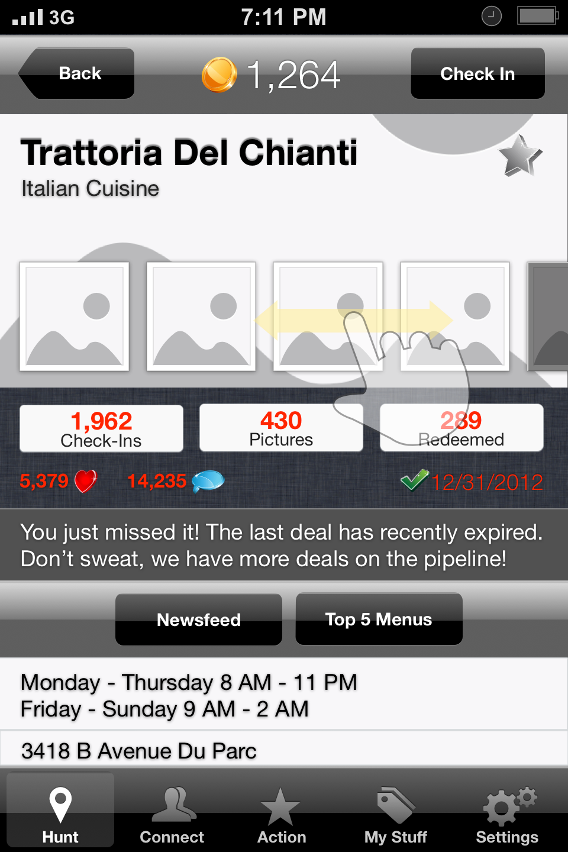

The Restaurant/Deal page will have Restaurant Name, Main Category, Image Slide, Favourite Switch, # Check-Ins, # Pictures, # Redeemed, # Likes, # Comments, Deal Expiry Date, Dollar Price, Coins Price, Get Deal button, Long Deal Description, Restaurant Newsfeed, Top 5 Menus, Hours, Address, Phone, Website and the Check In button.

The large image is the first or Main Restaurant Image that will also be used when representing the Restaurant in a list all throughout the application.

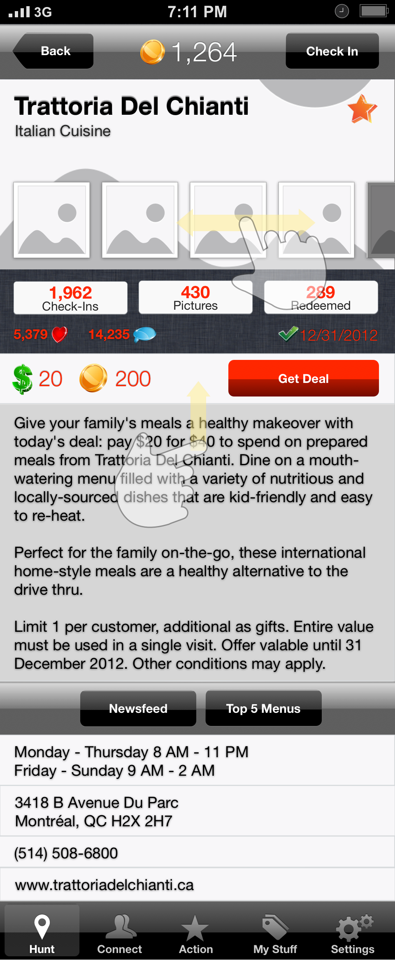

The star in the top right corner is the Favourite switch. It adds/removes the Restaurant from your Favourite list.

The other 2 buttons (# Check Ins and # Redeems) will display the respective lists. On the lists, present are: Username, Message, Time ago, # Likes, # Comments and # Coins Rewarded.

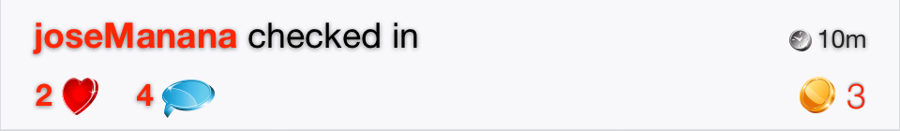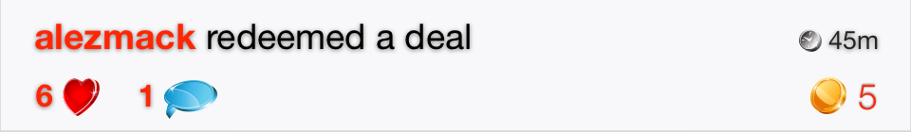

The **Image Slide** will be infinite and will start with the latest images posted. Clicking on an image will open that particular image in full screen. Clicking on the # Pictures will open the Restaurant Images screen. In the Restaurant Images screen, the owner pictures will be large, organized in a horizontal slider and the rest of the pictures taken by the users will be in the form of a grid with the latest on top. They behave similar to “My Pictures” above. The only difference is that the owner’s pictures only open in full screen, skipping the post screen step.

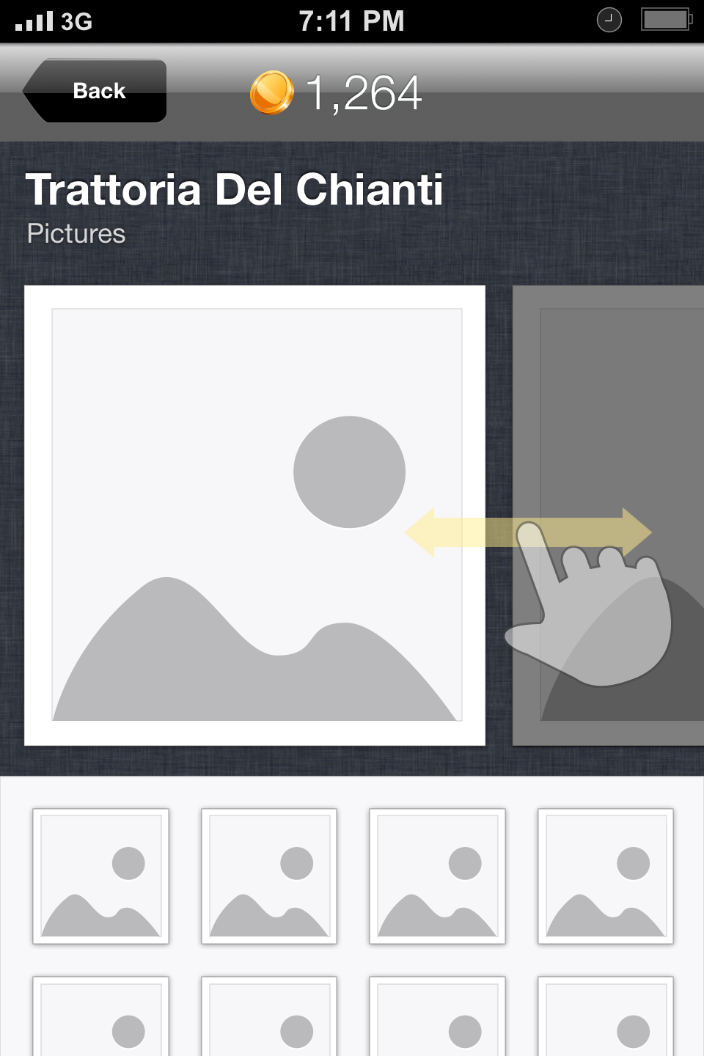

**Restaurant Newsfeed** displays all the actions taken by people (check ins, likes, new pictures, redeems, favourites, gifts) in regards to the Restaurant. This is very similar to “My Newsfeed” above.

**Top 5 Menus** allows vendors to publish (via Vendor Management Website) up to 5 signature dishes with Name, Description and Price. The 5 menus can be liked by CityHunter’s users individually.

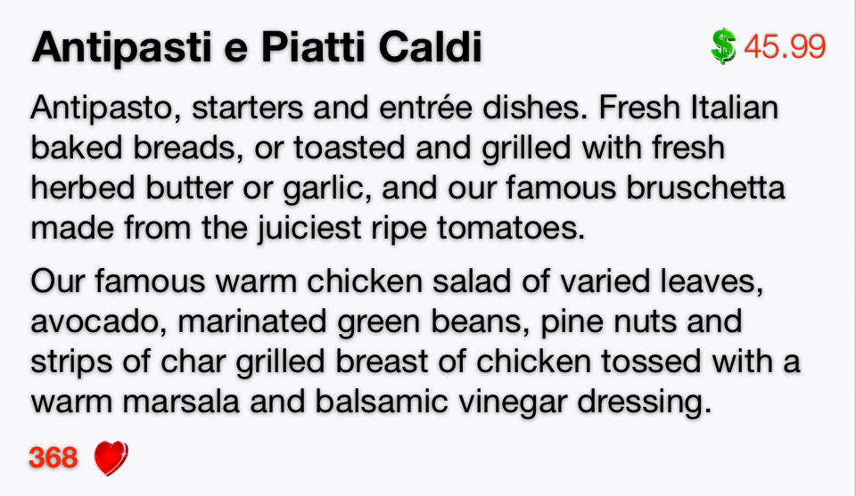

Clicking on the **Address** will open the map with the Restaurant location. The exact location will be centered on the map, with a pin and a pop-up similar to the Hunt screen but only displaying Restaurant Main Image, Restaurant Name, 2 line Address and an arrow that will open Apple’s Maps application for directions.

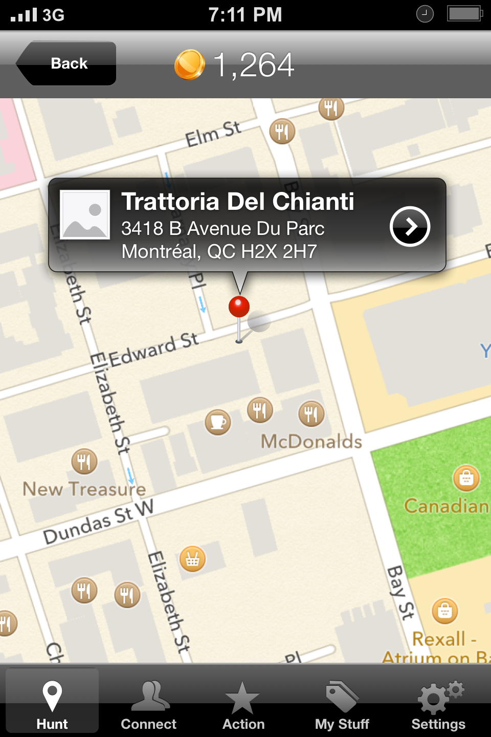

The **Website** (if exists) will open the restaurant website in a browser-like window within the application. The navigation bar will have Back, Forward, Refresh and Share buttons. Share will open a bottom screen slide with the options to Open in Safari, Share Link and Cancel.

## Purchase Deal

This screen can be accessed from the Restaurant/Deal screen by clicking on the Get Deal button. It will only show the selected deal, not all 3 (even if available).

This screen shows Restaurant Main Image, Restaurant Name, Category, Deal Short Description, Dollar Price, Coins Price, a drop-down for Quantity (if multiple deal purchase is accepted from the Vendor or Admin Management), Total, a Currency Slider, Payment Information, Confirm Purchase button, and the following switches: Keep this Private, Share on Facebook, Twitter and Weibo.

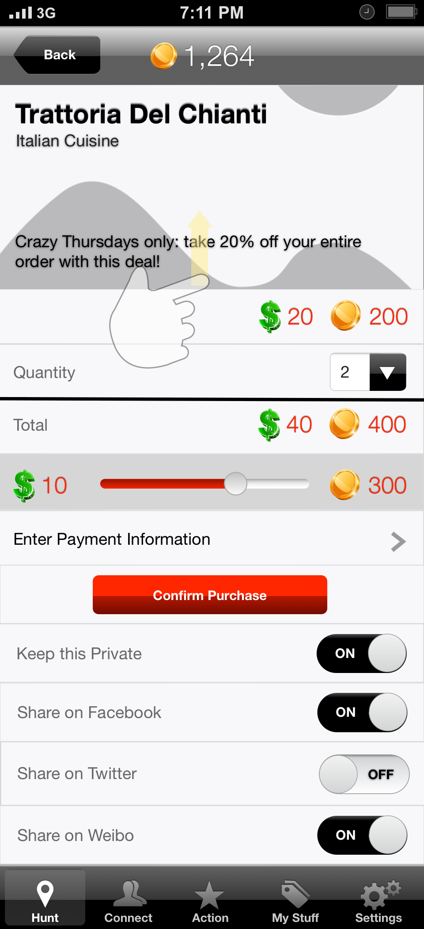

The Currency Slider allows leveraging the preferred method of payment between Dollars and Coins. A complete slide to the left means the user will pay the full price with Dollars and a complete slide to the right men’s he will pay the full price in Coins. Anywhere in between will change the 2 values proportionally. Click on either of the two currencies and the slider will automatically go to the respective extreme.

If there are not enough coins, the slider will not go full right - will stop at the maximum Coins balance.

Enter Payment Information will pull the Payment screen. Here, a user can manage up to 3 (see Moneris Vault limitations) credit cards. This uses Moneris Vault API.

Another payment option is PayPal (see Groupon App’s PayPal integration for reference).

Confirm Purchase button will only be enabled after a purchase method has been entered. After a successful transaction, the user is redirected to the Purchased Deals screen.

## Connect

**Connect** screen will display the events in a feed list. All the elements in the feed will be related to the people you follow (Following). Here we will see only the main messages like: check-ins, likes, picture posts, redeems, gifts, etc. There are two additional buttons on this screen: Newsfeed and Requests.

Newsfeed shows all the secondary messages pertinent to me, like: someone liked my check in, commented on my image, replied, etc.

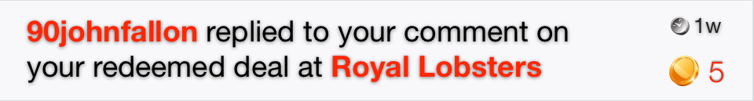

**Requests** is a section that will only be enabled if “Profile is Private” is set to ON in the Settings.

Users who wish to follow someone with a private profile will have to be approved in this screen. It has the Profile Picture, Username, # Coins and the Accept/Deny buttons. The line will automatically disappear once an option is selected.

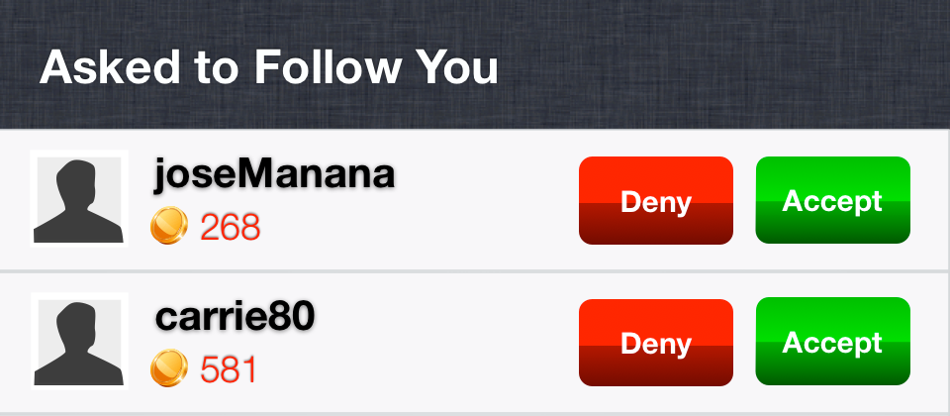

The default switch will be set to “Deny”. All the accepted entries in this section will be cleared instantly (or by navigating away). All the denied entries will be cleared automatically in 7 days after they have been seen.

Other user’s profile is very similar to My Profile. It can be accessed through the Username or the Profile Picture anywhere it appears.

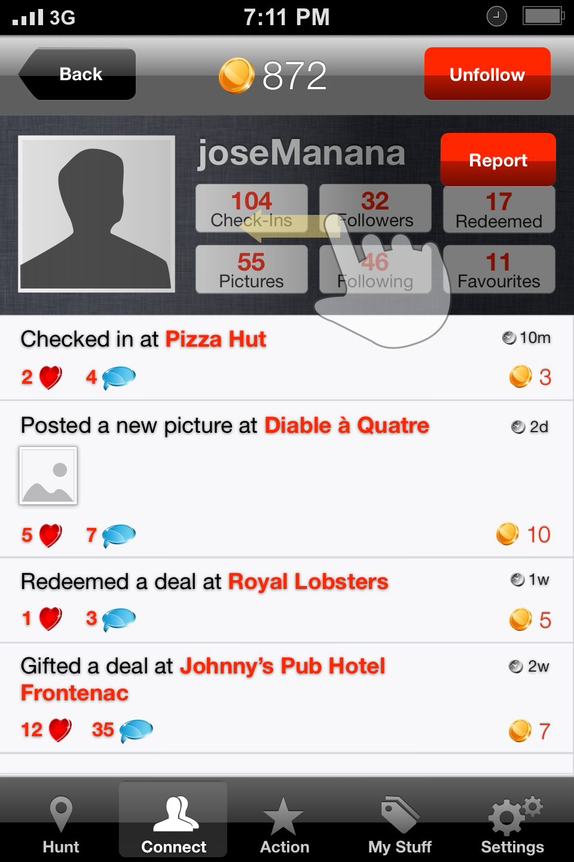

The Follow/Unfollow button acts like a switch. It says “Follow” if I am not following this user and “Unfollow” if I am following. If the user’s profile I want to follow is set to “Private” then after pressing “Follow”, the button will turn to “Requested” and will be inactive until I get accepted (turn to “Unfollow”) or denied (turn to “Follow”) and reactivated.

The 6 buttons under the Username will take you to that person’s Check Ins list, Pictures, Followers, Following, Redeemed and Favourites. No additional buttons will be displayed (for example in the follow/following lists there will be no “Follow”/”Unfollow” buttons).

## Action

Pressing on the **Action** button in the iconbar will open a pop-up with the following additional buttons: Check In, Snap, Use Deal.

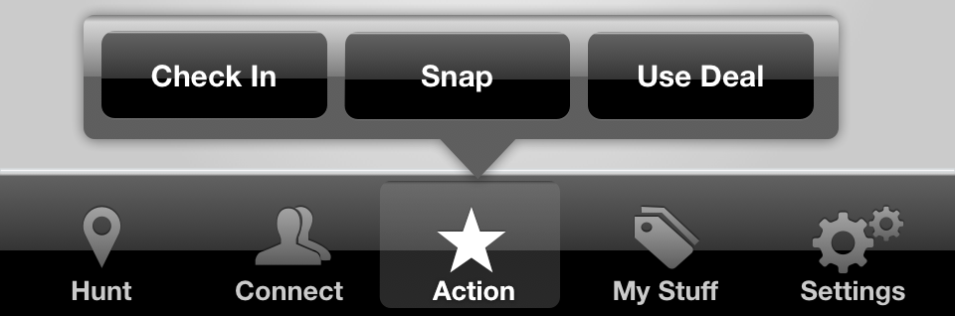

If the user clicks away the pop-up is hidden.

**Check In** enables a user to check in a location. This opens a list with venues close to user’s current location. Each restaurant displays the Main Restaurant Image, Name, # Likes, # Comments and distance. The user has the option to add a new location by choosing a restaurant not enrolled with CityHunter, but found through Foursquare’s API.

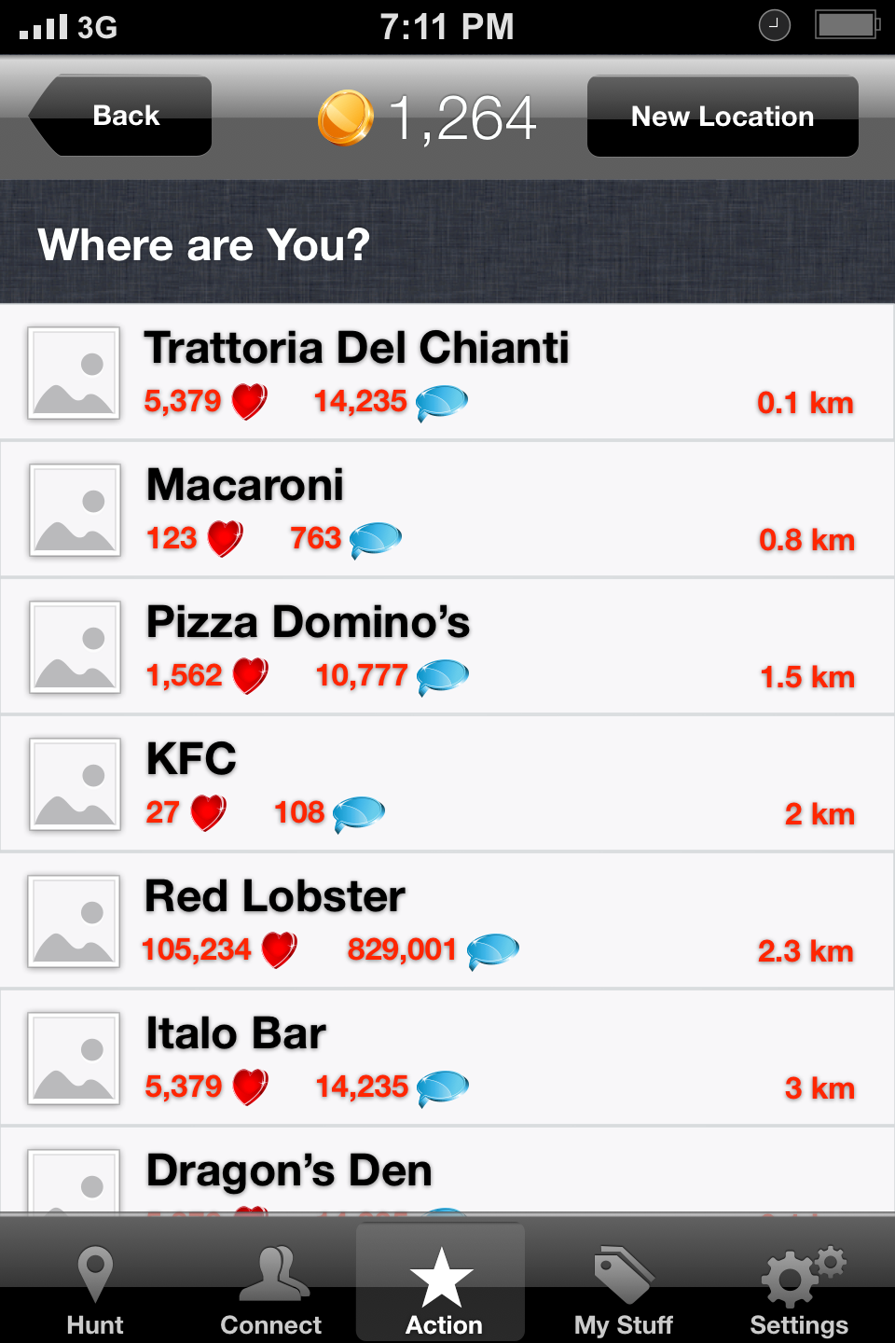

After a location has been selected, the user can add a comment (optional) and share with Facebook/Twitter/Weibo (optional) when posting.

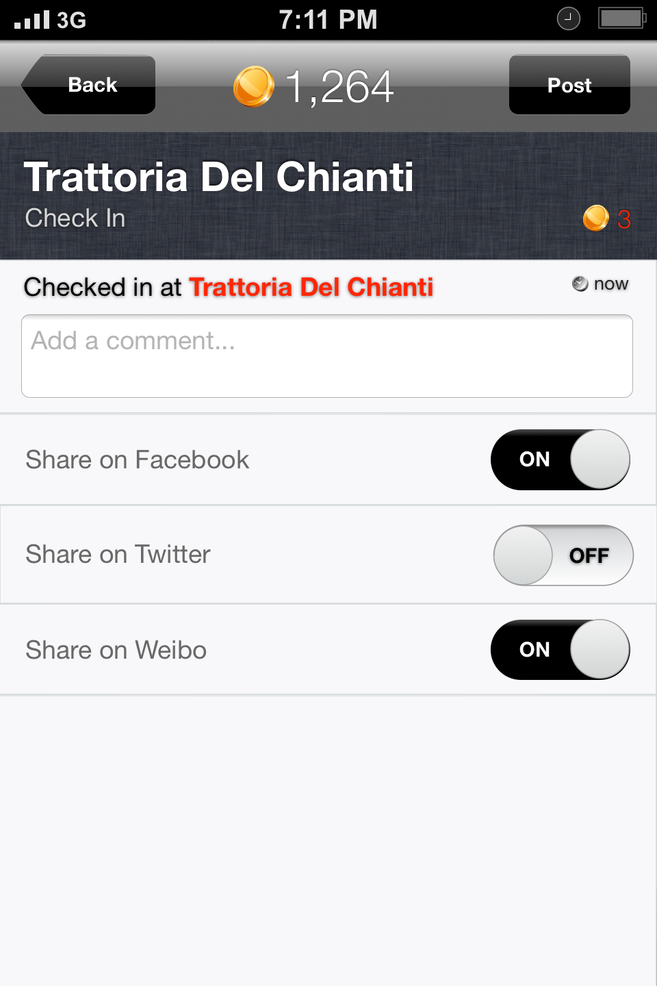

His followers will be notified about this event.

**Snap** enables users to share images taken on a restaurant premises. They can either select Snap Photo or Choose from Library.

It opens the built-in camera screen for taking a picture. If the user decides to use an existing picture from the Camera Roll, it must be then centered, scaled and cropped to a square shape. After this step has been completed, the user can select a location, add a comment, share on Facebook/Twitter/Weibo (similar to checking-in above) and post.

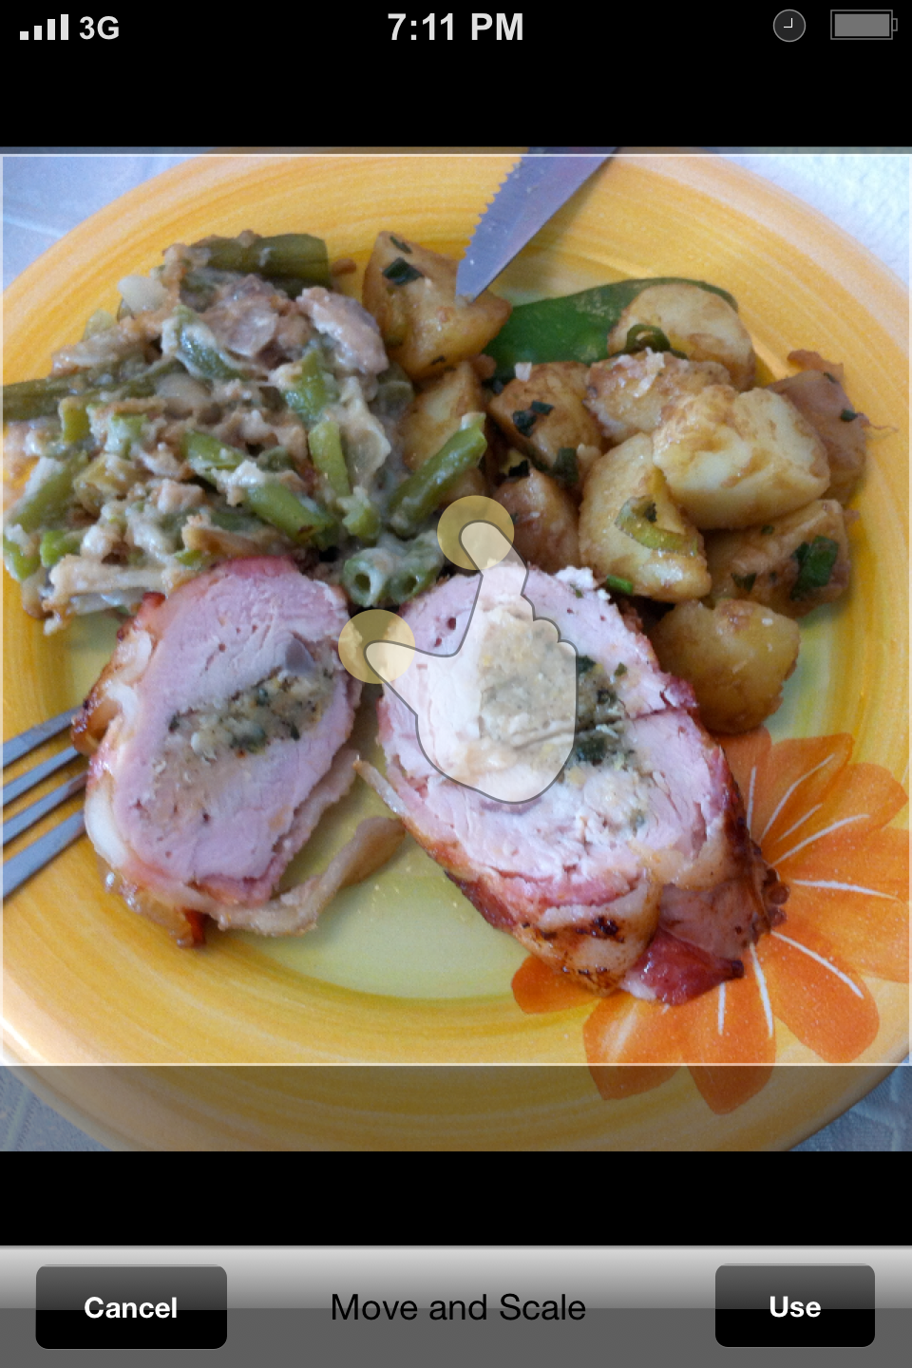

There will be a switch “Save to Camera Roll” which if set to ON will save a copy of the picture on the phone and if set to OFF, it will not. The default value is ON.

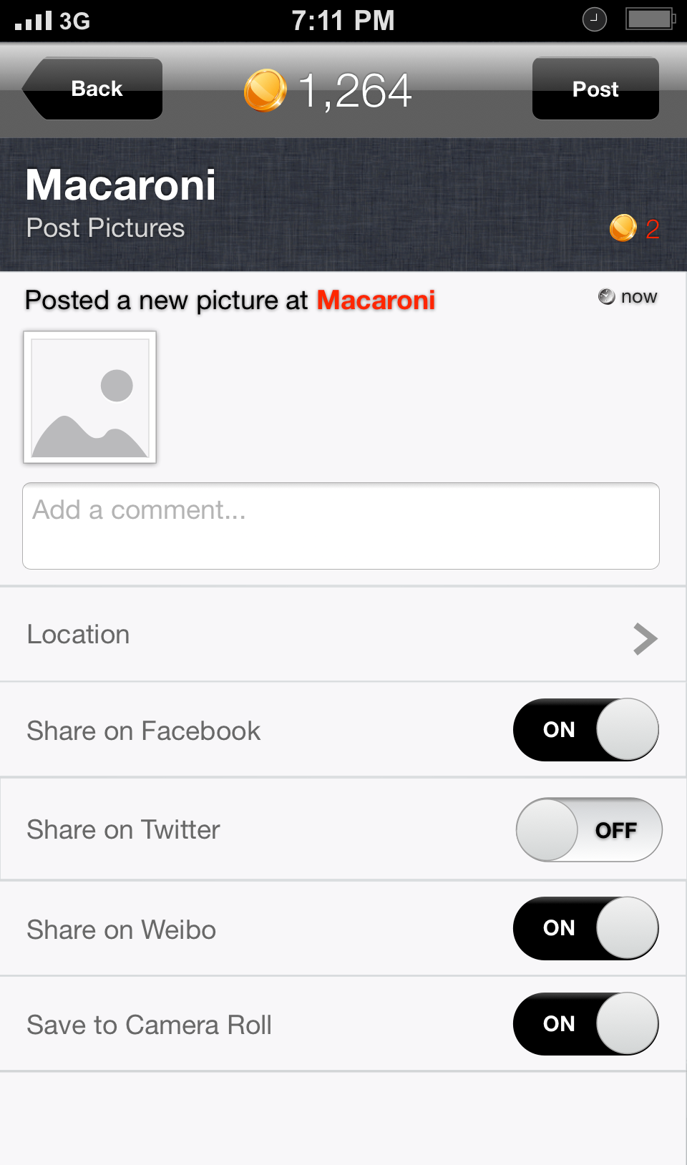

**Use Deal** opens the Nearby Deals screen. This is very similar with the Deals List in Hunt, except it doesn’t have the Search bar and the Filters button.

Note that here we will see the default Deal 1 for each Restaurant, with the only exception if a deal has already been purchased for a restaurant (case in which it will display the purchased deal).

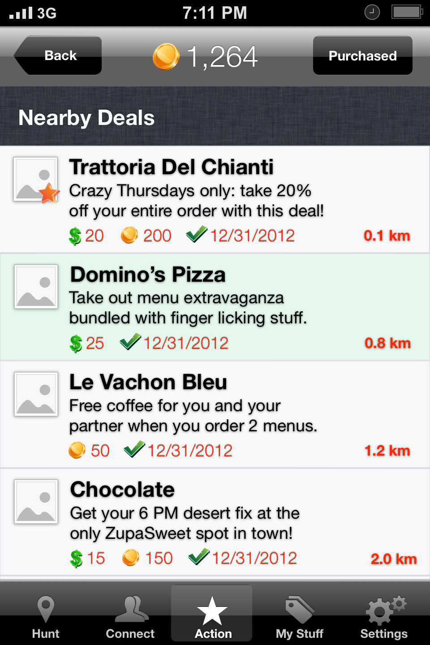

The green color suggests the Deal has already been purchased. The Expiry Date shows when the Deal is set to expire. Redeeming after this date is no longer possible. Expired Deals will be displayed in a “washed out” manner.

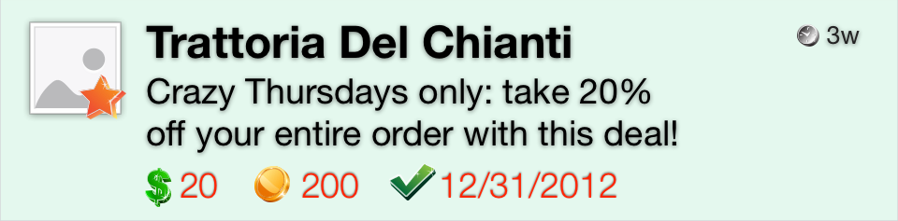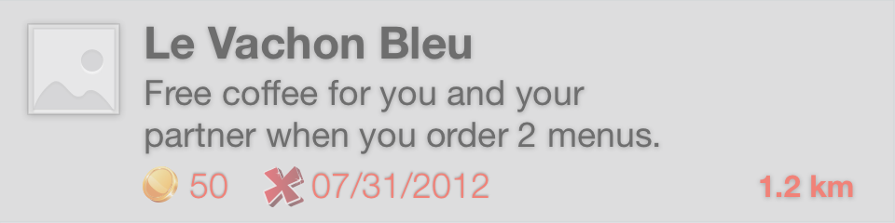

A Deal not purchased yet will open the Restaurant/Deal screen.

A purchased Deal will open the Purchased Deal screen, which is very similar with Purchase Deal screen above.

The Purchased Deal screen has: Restaurant Name, Category, Main Restaurant Image, Short Deal Description, Coin and/or Dollar value, Gift button, Redeem button, Purchase Date, Keep this Private switch, Share on Facebook/Twitter/Weibo switches and Long Deal Description.

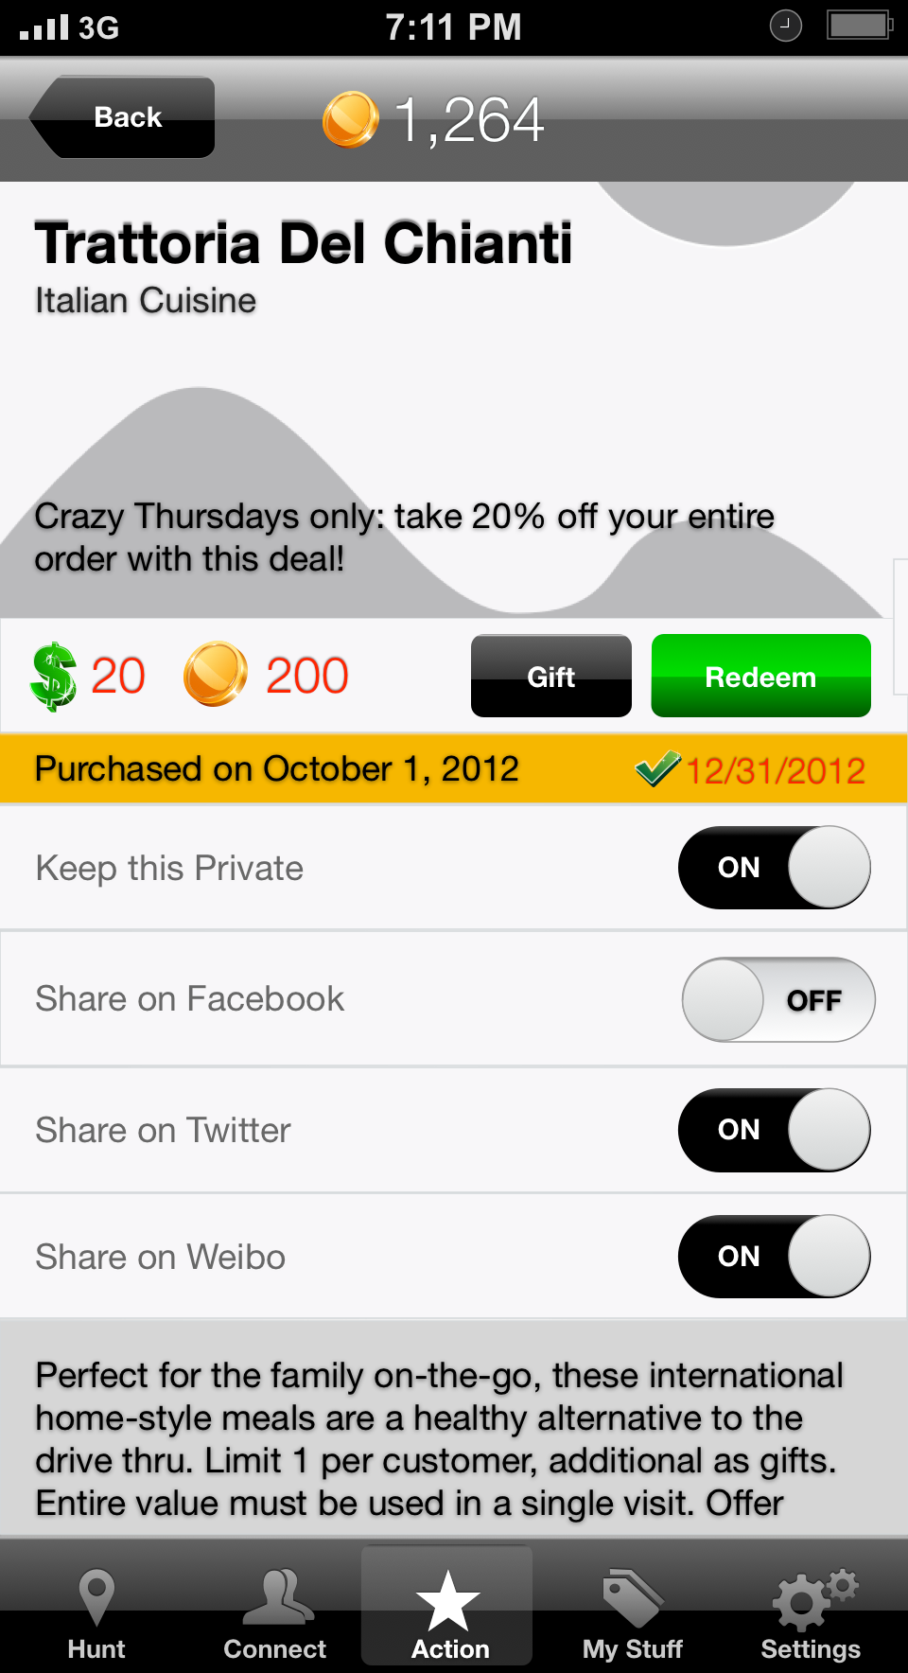

To **Redeem**, a user must press Redeem button. The pop-up will ask him if he wants to redeem for sure. He has to execute a Slide to Confirm operation in order to limit the accidental redeeming.

This will generate a unique code that must be presented to the waiter. The waiter can write this code down or not. The deal is considered redeemed once the code is generated. There is no going back at this point; the Deal will be flagged as Redeemed/Used on the server.

Once redeemed, the Deal must be transferred from Purchased Deals into Used Deals (see My Stuff below).

The restaurant owner must have the ability to verify the redeemed codes against their log, via Venue Management Website.

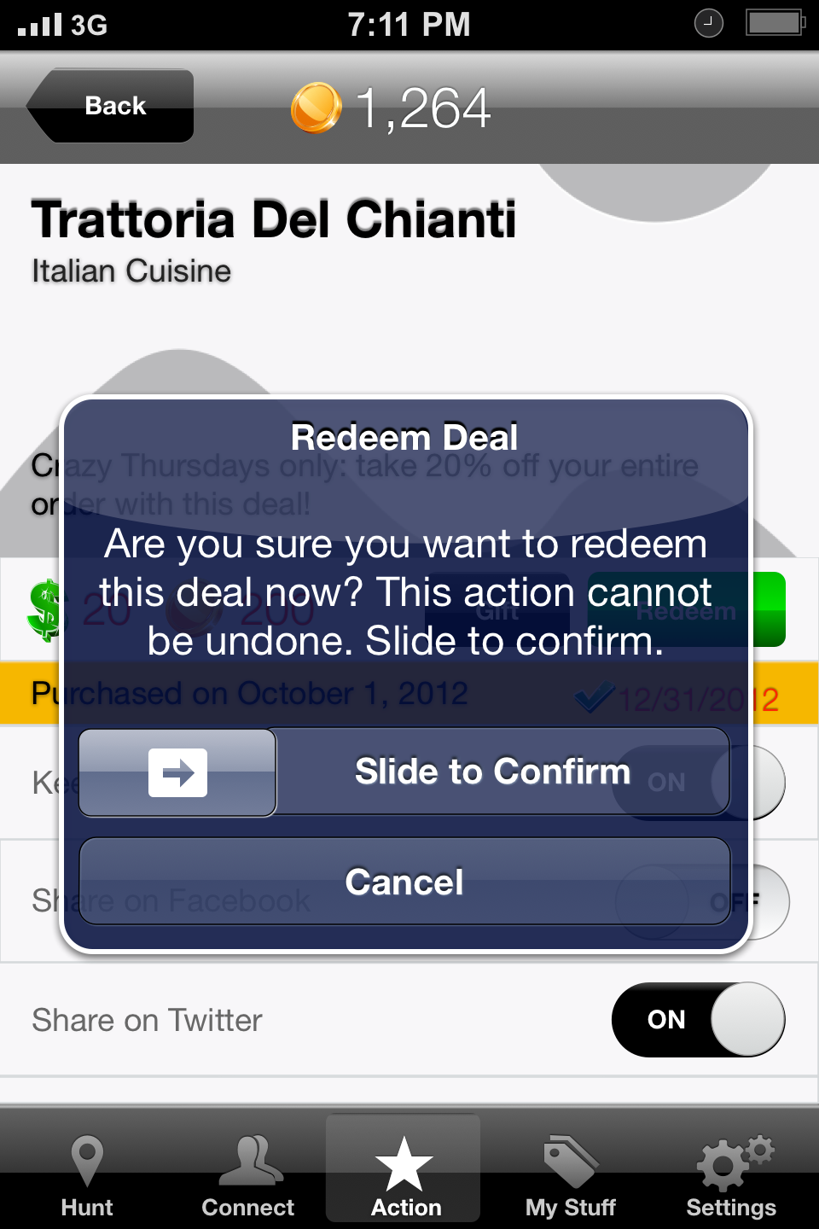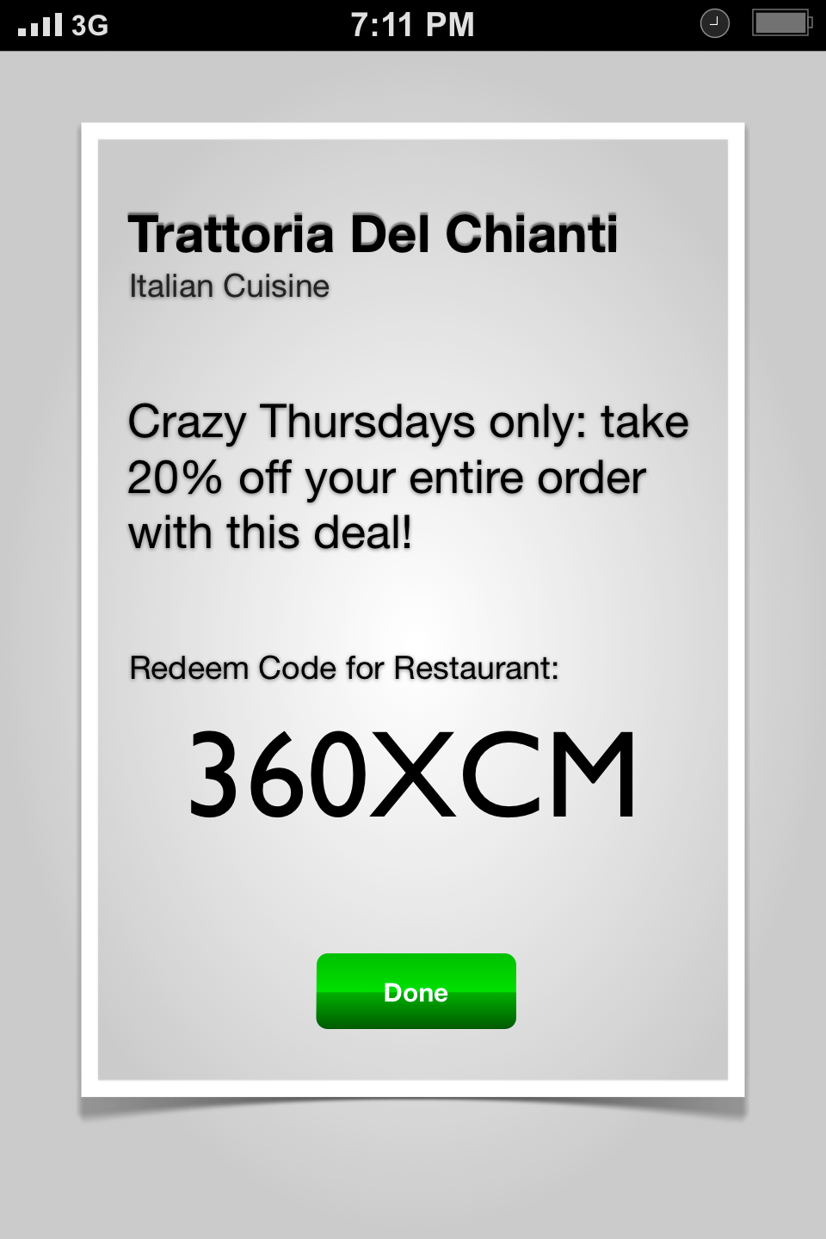

To **Gift** a Deal, the user must choose from the Following and Followers list or to send it by Email. After a short prompt, the Deal is transferred from the user’s Purchased Deals into the recipient’s Purchased Deals with the “Gift” icon instead of price (see Purchased Deals below). The gifted deals maintain the same Expiry Date before being rendered useless.

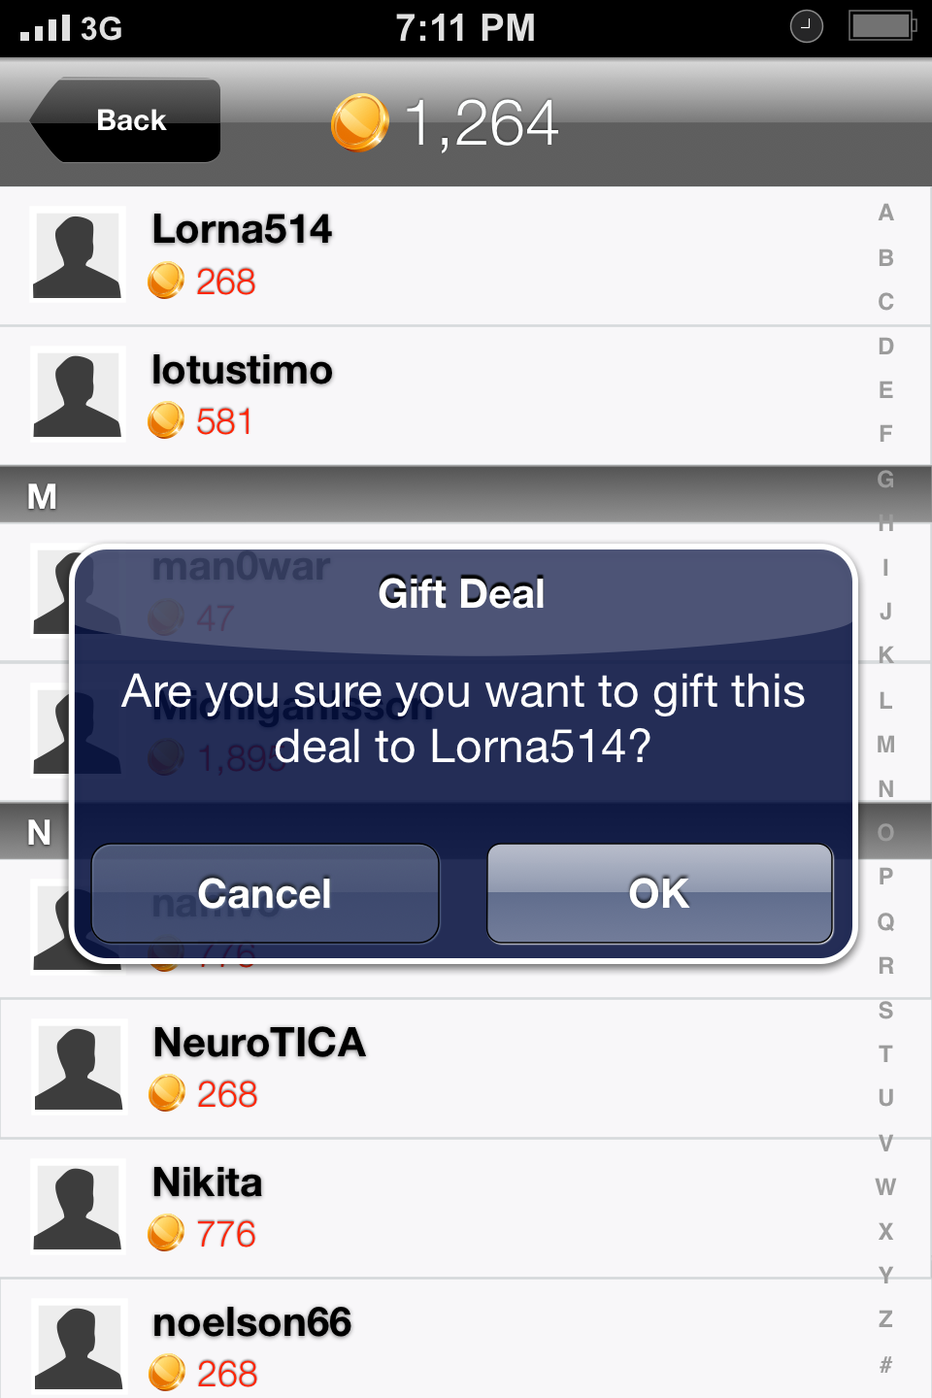

Gifting via email option opens the Compose Message screen with a pre-set message that can be altered (except for the URL).

The URL contains an auto-generated code, which upon access will inform the system it has been clicked and will open CityHunter in the App Store.

The recipient of this Gift either is a member of CityHunter and the Deal gets transferred painlessly (without the need of using the URL – it gets disabled) or he is not a member. To benefit from this Gift, the recipient must sign up to CityHunter using this email address (via the provided URL). The email address can be changed later from Settings.

If the system does not recognize the email address of an existing CityHunter member (i.e.: he is registered with a different email address), just by accessing the URL from a device with CityHunter App installed, will transfer the Deal to this account automatically.

## My Stuff

**Purchased Deals** lists all previously purchased deals and received gifts that were not used yet. It’s very similar to Use Deal section. The Deals will be listed in chronological order based on the Expiry Date (first to expire on top).

**Used & Expired Deals** lists all the previously used or expired deals as the name says. Used Deals must be ordered by reverse chronological order of usage (last one used on top). Expired Deals must be ordered in reverse chronological order based on the Expiry Date (last expired on top) and all Expired Deals grouped under Used Deals.

Note that here we will see the deals that have been purchased (not Deal 1 by default).

The Used Deals will also display the code.

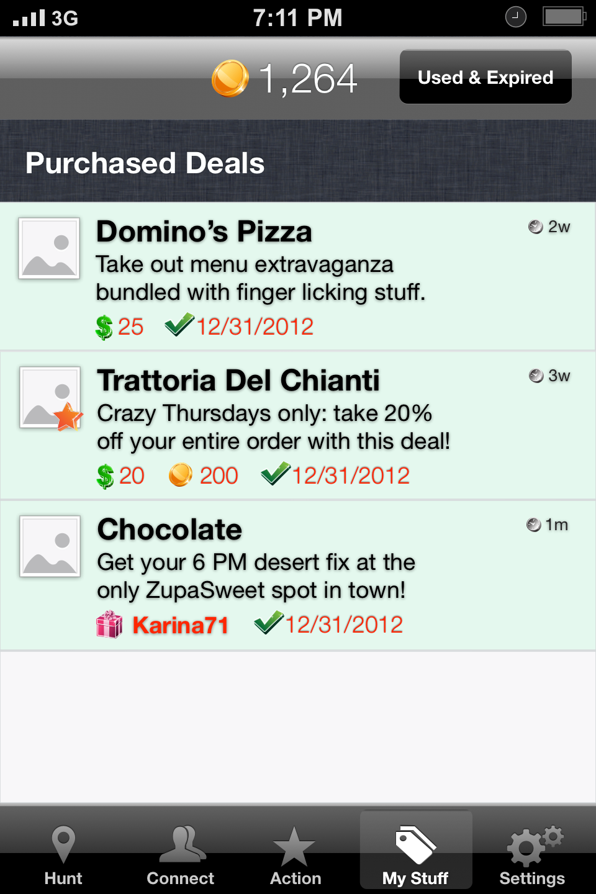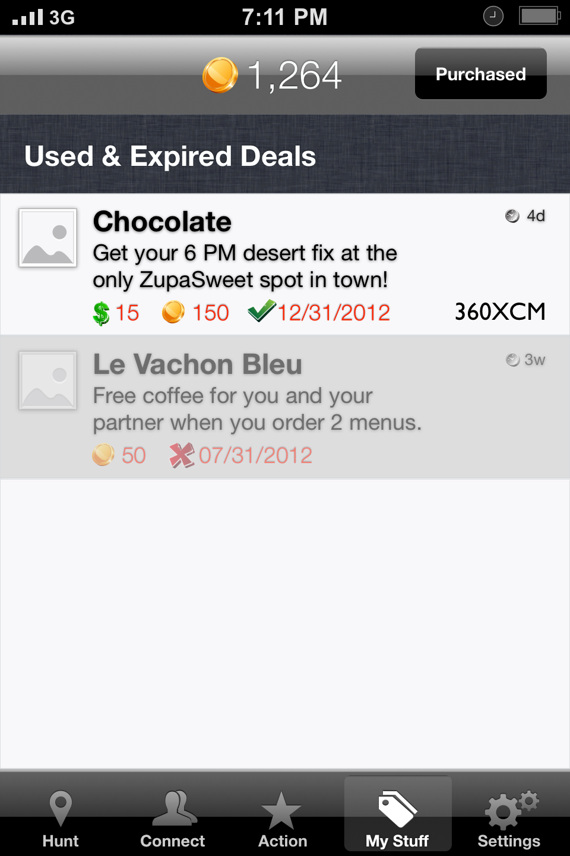

## Settings

**General Settings** include: Edit Profile, Profile is Private switch, Invite Friends, Find Friends to Follow, Share Settings, Distances switch, Passcode switch, Opening Screen drop-down and Log Out.

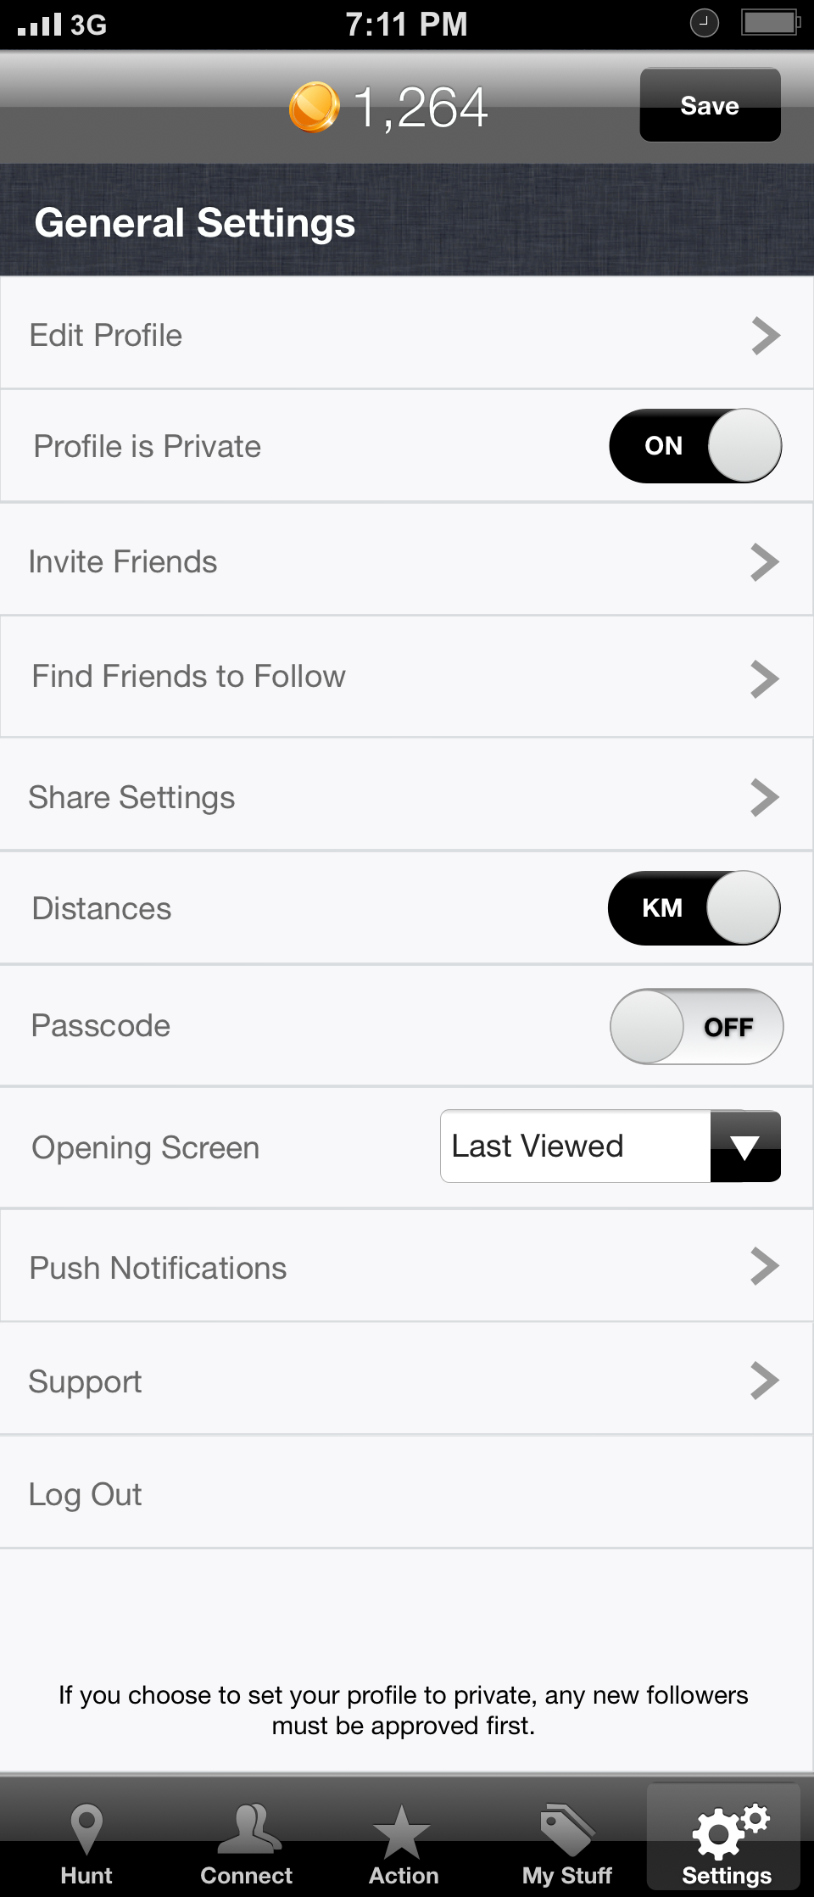

**Edit Profile** will allow a user to manage his account. From here, the following information can be changed: Username, First Name, Last Name, Email, Profile Picture, Location, Phone, Birthday and Gender.

To change the **Profile Picture**, simply click on the picture and a screen slide from the bottom will prompt for action: Snap Photo, Choose from Library or Cancel. The picture must be cropped to 1:1 aspect ratio from within the application, similar to all picture sharing on CityHunter.

The **Gender** drop-down will have the following options:

* Male
* Female
* Undisclosed

**Profile is Private** will allow users to determine whether or not their profile can be followed by others. If set to ON, all the follow requests will be banked in the Requests screen before being approved (see Connect above).

**Invite Friends** offers 3 ways of finding and inviting one’s friends to use the CityHunter app: Address Book, Facebook and Weibo.

The first time, **Address Book** will display a pop-up with permission request for accessing the phone’s Contacts. The address book contacts will be displayed in a list. Click on any name and enter directly in Compose Message. It can be an SMS, MMS or iMessage.

**Facebook** and **Weibo** (after granted access), will have a similar list with checkboxes beside each contact. Default will be checked for all. The user has the option to select/unselect all. Click on Invite button and all the contacts will receive an invitation via email.

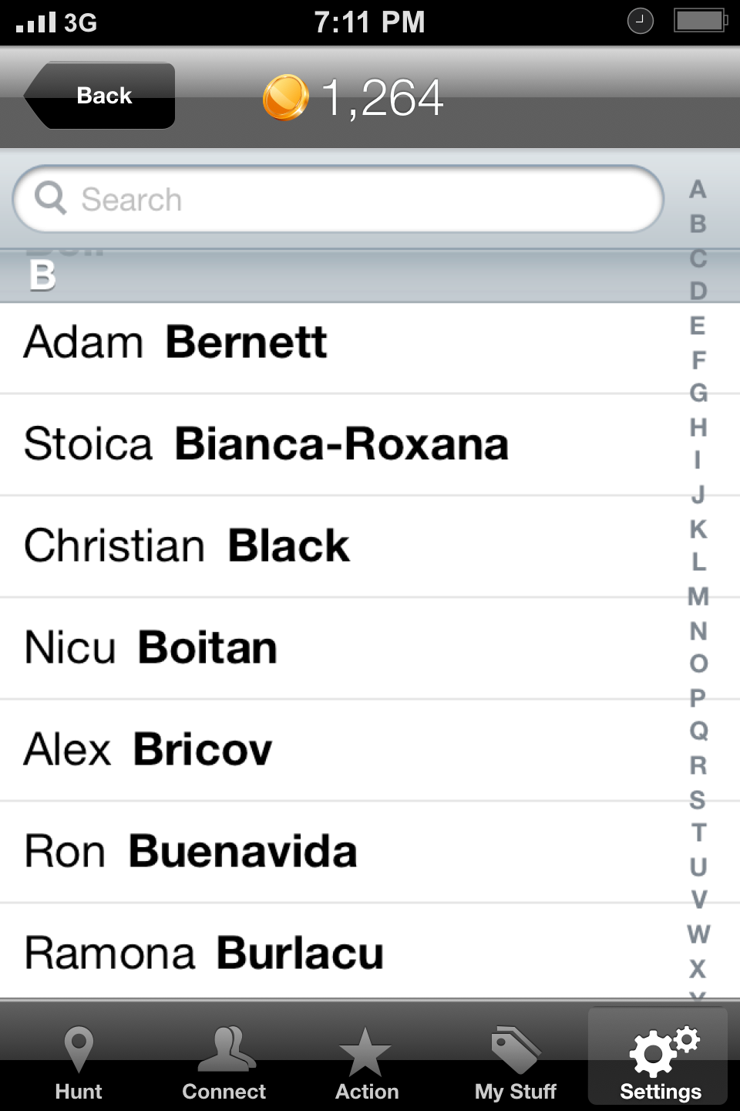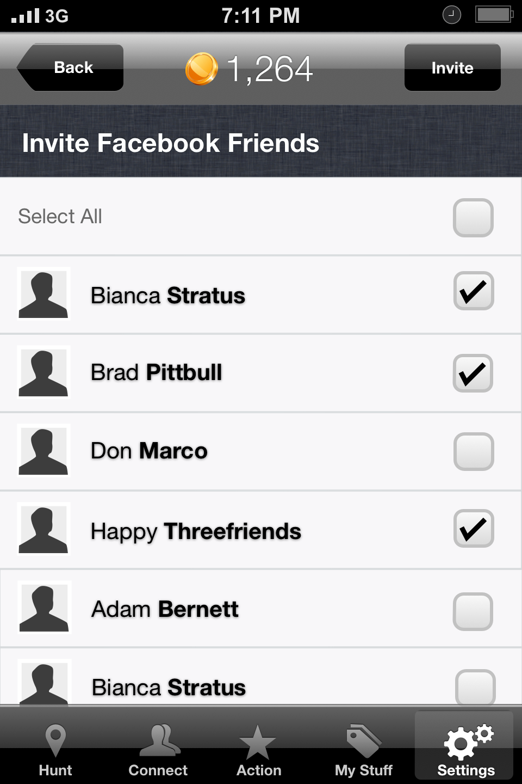

**Find Friends to Follow** is very similar in approach with Invite Friends. It has the same Address Book, Facebook and Weibo options. CityHunter must match the contact lists of the user and the database. If there is any of the user’s friends/contacts already using CityHunter, then they will be presented in a list with Name, # Coins and with a Follow/Unfollow button next to the name.

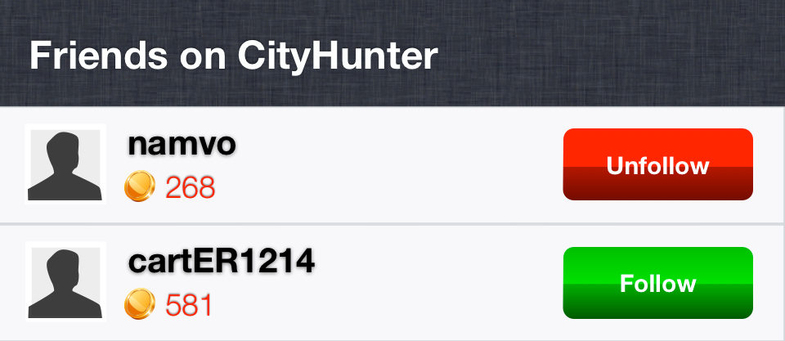

Share Settings is a place where Facebook, Twitter and Weibo can be Linked/Unlinked with CityHunter via their APIs.

**Distances** switches between KM or MILES. Default is KM.

For **Passcode** operation refer to Opening the App section above. The switch can be turned ON or OFF. Default is OFF. When switched to ON, the user will be prompted to type in a 4 digit passcode. Once 4 numbers have been entered, the user will be prompted again to confirm them.

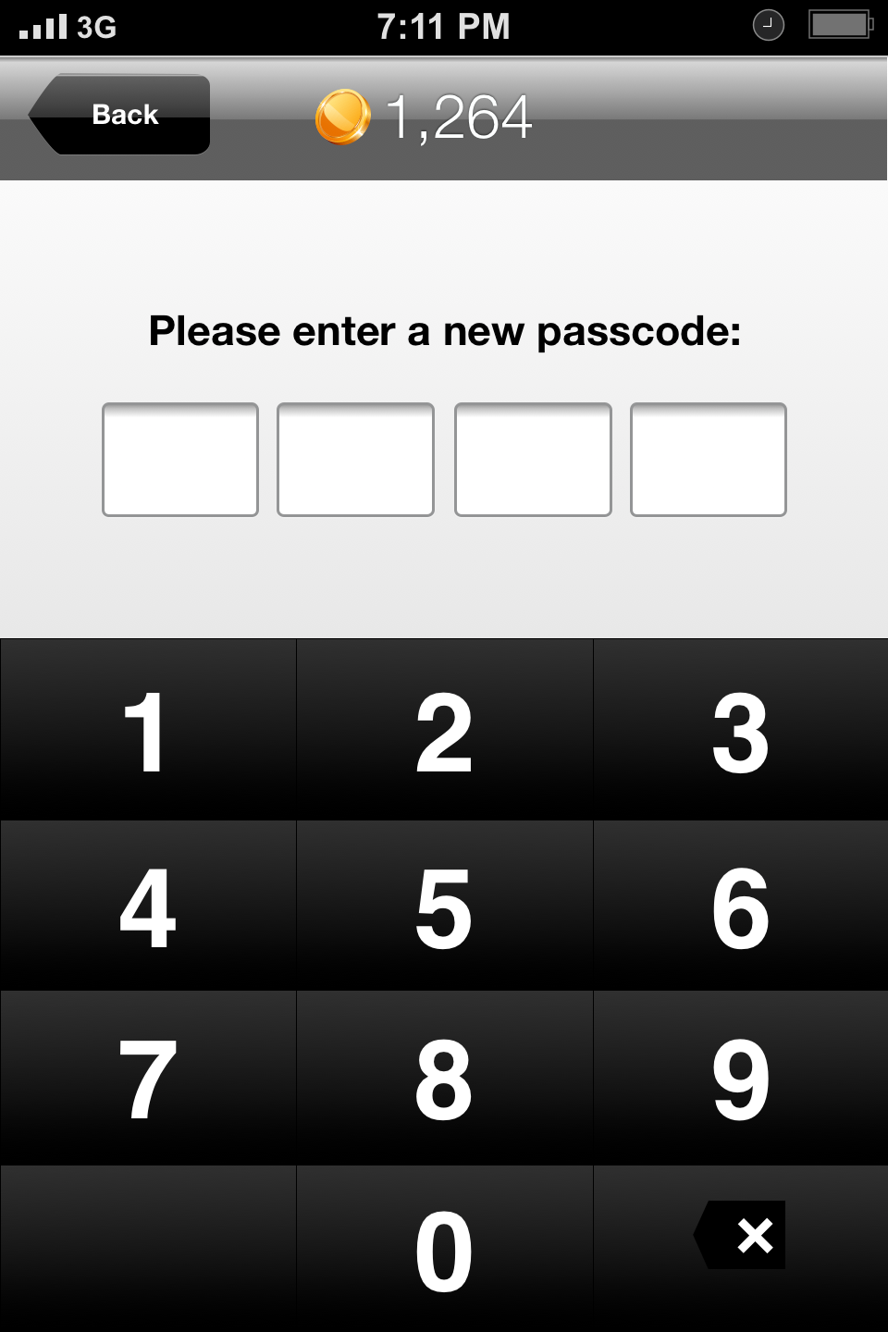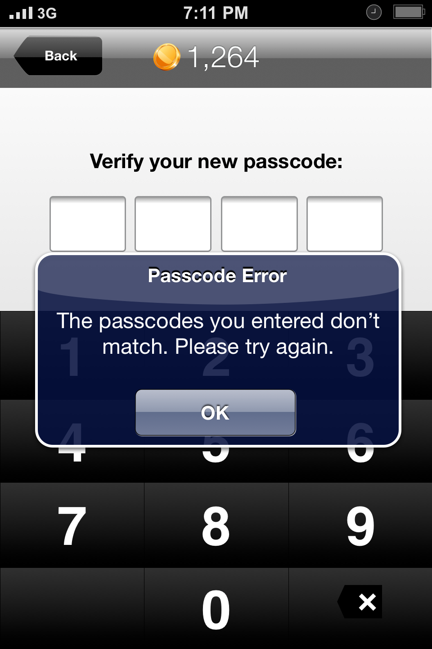

If successful, will display a pop-up message saying it was set and go out to General Settings (see Copy below). If not successful, will display a different pop-up message with the request to try again. The passcode setup will restart.

**Opening Screen** allows the user to select where will the app open by default when invoked. Options are:

* Last Viewed (it’s the last viewed screen and is set by default)
* Hunt
* Connect
* My Stuff

**Push Notifications** will let the user determine which types of notifications will be sent through “push services” to their device. The options are as follows:

Likes:

* From Everyone (default)
* From People I Follow
* Off

Comments:

* From Everyone (default)
* From People I Follow
* Off

Contact:

* All New Contacts (default)
* Off

**Support** is just a list of web links. Those pages will be maintained and updated regularly via the CMS. We should use the internal browser to open them (for consistency purposes).

## Other General Requirements

All the Profile Pictures and Pictures (venue shots, etc.) will have a 1:1 aspect ratio (square). The images will have to be scaled and repositioned within the App before being accepted and used. The images will be stored on the server in 3 pre-determined sizes for small, medium and large (see design requirements) and used accordingly.

Double tap on a photo will automatically like it.

The Time since publishing will follow a specific format: now, 1m, 2m, 3m, … 59m, 1h, 2h, 3h, … 23h, 1d, 2d, 3d, … 6d, 1w, 2w, 3w, 4w, 5w, … 52w, 1y, 2y, 3y, … etc.

At any time, swiping over a feed entry (post, photo, comment) will reveal a Delete button (applies to ‘my’ content only!) which will allow immediate removal or a Report button (applies to ‘other’s’ content only!) which will flag it as “Inappropriate content” and a note will be sent to Admin. If the button is not tapped, but instead the user taps outside the button area, the button will be dismissed.

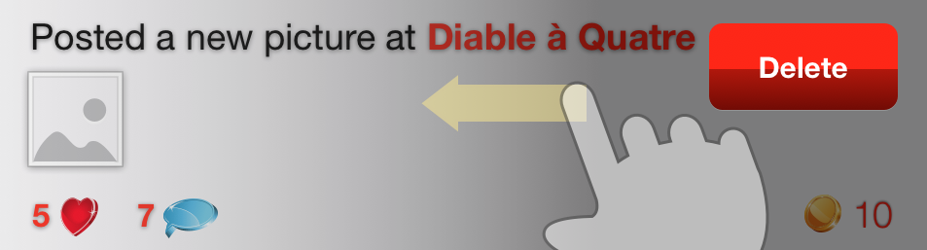

The same swiping action performed over someone else comment will reveal an additional Reply button. Tapping on it will open the comment box and will pre-fill in the username of that user in the following form: “@Username”.

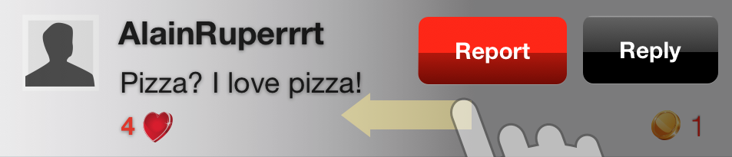

It is also possible to report a restaurant.

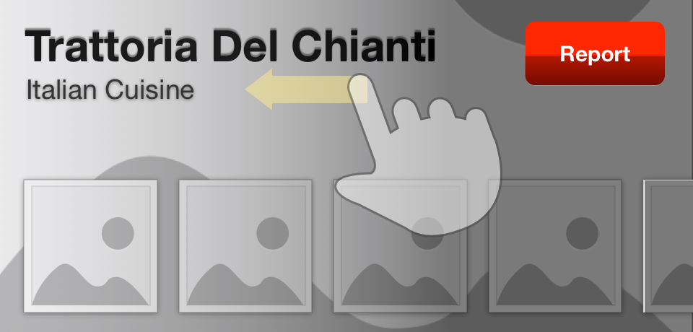

At any time a user pulls down a list (Newsfeed, Restaurants, etc.), the list will refresh. A message indicating the refresh action will be displayed during the refresh time.



Double-tap on an image to like it.

If there are any people who liked a entry, a list with their usernames will be visible above the comments. It will fit up to 5 usernames and keep count of the total.

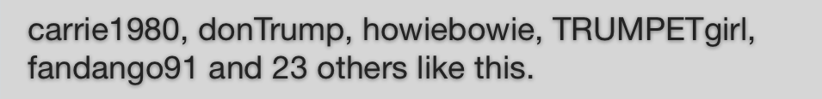

This list will open a new screen with a scrollable list of the users. Each item will include Profile Picture, message “Username liked this” and # Coins.

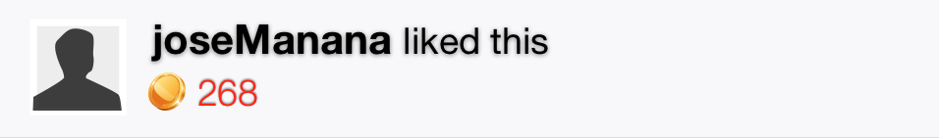

The Username cannot contain special characters other than “.”, “-” and “_”.

If the activity Message (from the feed list) is about a picture post, then a thumbnail of the image will also be displayed in the feed.

The # Likes works like a button. It will be considered a “like” if pressed and it will be ignored if pressed again thereafter.

Likes cannot be liked or commented. When a record in the Newsfeed shows that a user liked a Restaurant or a menu, it will link to that specific Restaurant.

Check-ins are limited to a maximum of 4 per day.

## Emails

Email communication must be created for the following events:

* new registration
* retrieve lost password
* you have received a gift
* deal purchase invoice
* you are invited to join

## Notifications

Whenever CityHunter needs to send out a global notification to the users through the application, will do it from the CMS with the help of a two-line message visible at the top of the Newsfeed.

Admin will be able to enable/disable this global notification, change the wording (limited to 2 rows, approx. 100 chars.) and add an optional URL. By tapping the global notification, it will open the URL in the dedicated browser.

The global notifications could be for example: *“Cityhunter has updated its terms of use.”* (tapping "terms of use" will link to it) or *“CityHunter is giving you double coins this weekend! See details here!”* (link to a promote page or screen).

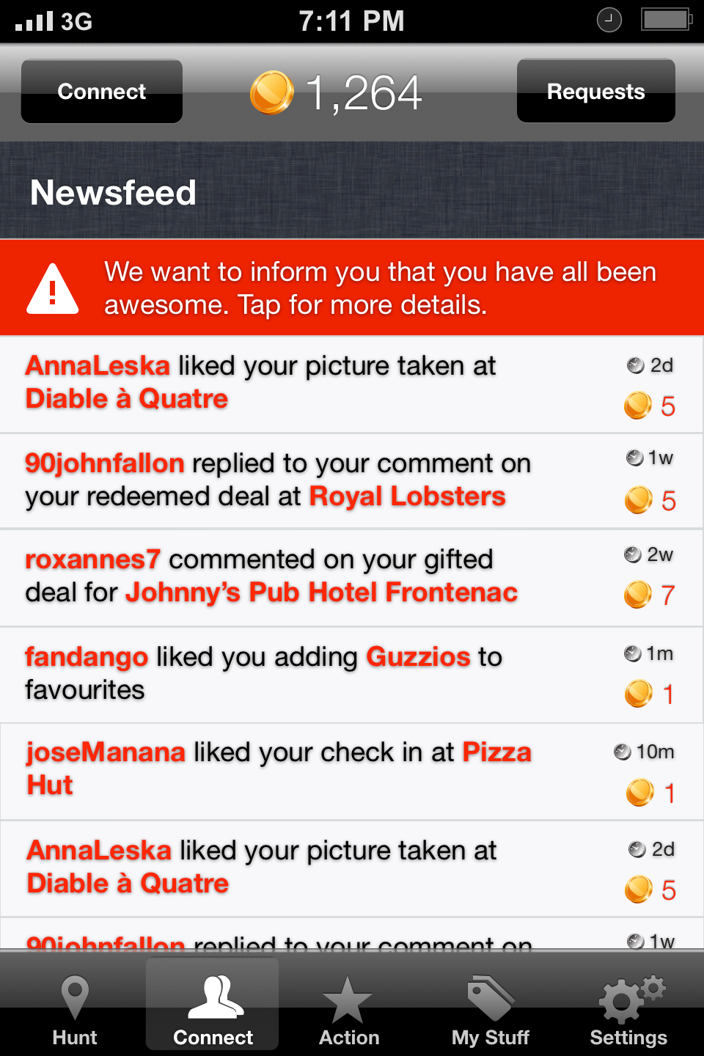

Connect Newsfeed events (see Copy below) require notifications to be sent to the phone.

The Alerts will be fully configurable via iOS Notifications. By default, all the Alerts, Banners, Badges, Sounds and the Notification Center will be enabled.

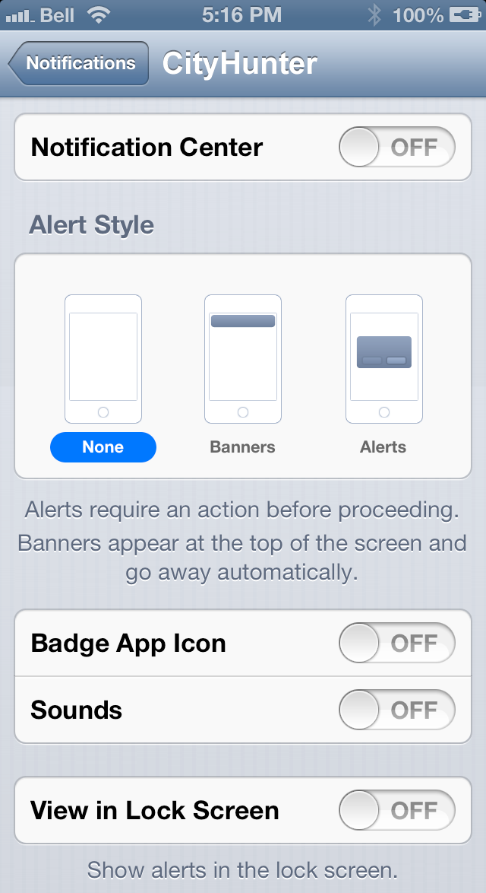

## Copy

**Registration Errors:**

* Field cannot be blank
* Username already taken
* Only “.”, “-”, “_” special characters allowed
* Emails provided don’t match

**Login:**

* Field cannot be blank
* Email unrecognized
* Wrong password
* Forgot password?
* Retrieve Password. The password has been successfully sent to your email address.
* Retrieve Password. No such email address in our database.

**Profile:**

* Likes «RESTAURANT»
* Checked in at «RESTAURANT»
* Posted a new photo at «RESTAURANT»
* Redeemed deal at «RESTAURANT»
* Gifted a deal for «RESTAURANT»
* Added «RESTAURANT» to their favourites

**Restaurant Newsfeed:**

* «USERNAME» likes this restaurant
* «USERNAME» likes this restaurant item
* «USERNAME» checked in
* «USERNAME» posted a new photo
* «USERNAME» redeemed a deal
* «USERNAME» gifted a deal
* «USERNAME» added us to their favourites

**Connect:**

* «USERNAME» likes «RESTAURANT»
* «USERNAME» likes «RESTAURANT» menu
* «USERNAME» checked in at «RESTAURANT»
* «USERNAME» posted a new photo at «RESTAURANT»
* «USERNAME» redeemed deal at «RESTAURANT»
* «USERNAME» gifted a deal for «RESTAURANT»
* «USERNAME» added «RESTAURANT» to their favourites

**Connect Newsfeed:**

* «USERNAME» likes your check in at «RESTAURANT»
* «USERNAME» likes your «PHOTO»
* «USERNAME» likes your deal «REDEMPTION» at «RESTAURANT»
* «USERNAME» likes you gifting a deal for «RESTAURANT»
* «USERNAME» likes you adding «RESTAURANT» to favourites
* «USERNAME» commented on your check in at «RESTAURANT»
* «USERNAME» commented on your «PHOTO»
* «USERNAME» commented on your deal «REDEMPTION» at «RESTAURANT»
* «USERNAME» commented on you gifting a deal for «RESTAURANT»
* «USERNAME» commented on you adding «RESTAURANT» to favourites
* «USERNAME» replied to your comment
* «USERNAME» sent you a gift for «RESTAURANT»
* «USERNAME» requested to follow you
* «RESTAURANT» partnered with CityHunter
* «RESTAURANT» has a new deal

**Passcode Pop-Ups:**

* Passcode Set. The passcode has been set successfully.
* Passcode Error. The passcodes don’t match. Please try again.
* Reset Passcode. Would you like to reset the passcode? If you do, you will have to login again.

**Register Account Footer:**

* By registering an account, I accept CityHunter’s Terms & Conditions and Privacy Policy.

**New Restaurant Vote Pop-Up:**

* Vote Received. Thank you for recommending this location to CityHunter!
* Vote Not Received. Please try again later.

**Payment Information Footer:**

* All information will be sent over a secure connection.

**Purchase Deal Pop-Up:**

* Deal Purchased. Thank you for using CityHunter!
* Transaction Rejected. Please make sure the information provided is correct.

**Redeem Deal Pop-Up:**

* Are you sure you want to redeem this deal now? This action cannot be undone. Slide to confirm.
* Deal Redeemed. Thank you for using CityHunter!

**Gift Deal Pop-Up:**

* Are you sure you want to gift this deal to «USERNAME»?
* Your gift has been successfully sent.
* Gift Not Sent. Please try again later.

**Gift Deal Invitation Email:**

* I have a gift for you from CityHunter

I have been using the CityHunter app to find incredible deals at local restaurants and would love for you to join and start following me.

Until then, here is a gift for you: http://get.cityhunterapp.com/.

Your friend.

**Invite Friends Pop-Up:**

* Address Book Friends. In order to reach your friends, CityHunter needs access to your address book.
* Invitation Sent. The invitation has been successfully sent.
* Invitation Not Sent. Please try again later.

**Invite Friends Email:**

* Follow me on CityHunter

I have been using CityHunter to find incredible deals at local restaurants and would love for you to join and start following me.

Get the free app from here: http://get.cityhunter.com/.

Your friend.

**Settings Footer:**

* If you choose to set your profile to private, any new followers must be approved first.

**Report Inappropriate Content Pop-Up:**

* Comment Reported. Thank you!
* Picture Reported. Thank you!
* User Reported. Thank you!
* Restaurant Reported. Thank you!

**Misc:**

* Pull down/Release to refresh
* CityHunter requires an internet connection

# Web - Content Management

to be added

# Web - Venue Management

to be added

## Sample Screens

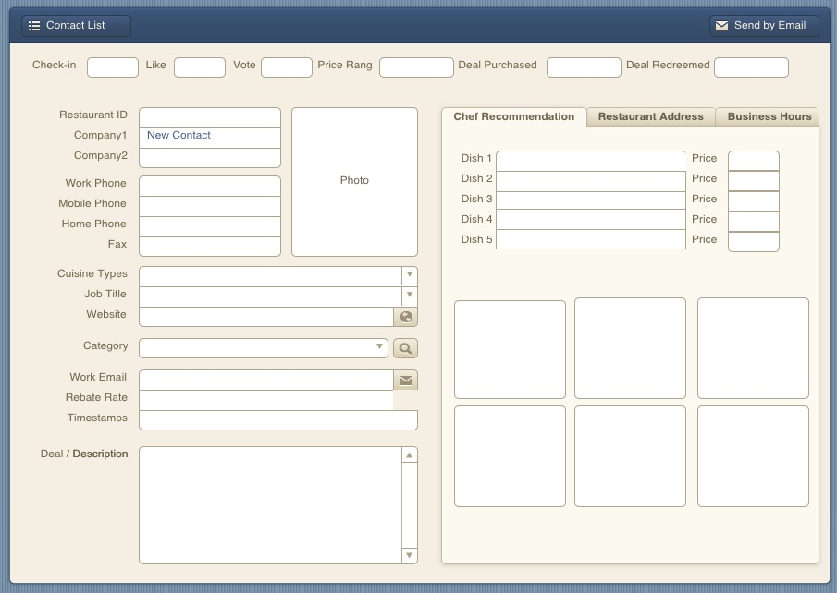

# Web - Services

Server to send out Expiring Deal Notifications:

* 14 days left “Only 14 days left to redeem the deal at «RESTAURANT». After this period the deal will no longer be available.”
* 7 days left “Only 14 days left to redeem the deal at «RESTAURANT». After this period the deal will no longer be available.”
* 2 days left “Only 14 days left to redeem the deal at «RESTAURANT». After this period the deal will no longer be available.”

This applies to all purchased deals that are not redeemed yet and will be sent via push notifications to the members who bought/received them.